2020380029 RAIHAN MD RAKIBUL ISLAM

2020380043 SHOAIB MUHAMMAD

Bachelor of Engineering in

Computer Science and Technology

Northwestern Polytechnical University

Dr. 林奕

Computer Science and Technology

Northwestern Polytechnical University

Abstract:

Our aim is to design a compiler for subset of C Programming Language. We are trying to implement the following features

Modules:

1. Lexical Analyzer

2. Syntax Analyzer

3. Semantic Analyzer

4. Intermediate Code Generator

1. Lexical Analyzer:

* Identification of Keywords, Identifiers, Operators (Relational, Logical and Arithmetic), Punctuators, Constants (Integer, Character and Float) and String Literals with invalid string error handling
* Single and Multi-Line Comments with error handling.
* Data Types (int, float and char) with modifiers (unsigned and signed) and types (short, long).
* Procedures with return type int, float and char.
* Parenthesis matching with error reporting.
* Invalid character identification and error reporting.

2. Syntax Analyzer:

In this phase syntax analyzers receive their inputs, in the form of tokens, from lexical analyzers. Checks the expression from this token are syntactically correct. We are trying to implement following features.

* Syntax Checking for arithmetic, logical and relational expressions.
* Productions rules for control statements such as if, if else and nested if statements.
* Production rules for unary plus and minus.
* Production rule and syntax checking for ‘for’ loop and nested for loop.
* Syntax checking for function declaration and parameter passing.
* Array indexing syntax errors.
* Scanf and printf syntax errors.
* Missing semicolon and unbalanced parenthesis.

3. Semantic Analyzer:

In this phase, we extract necessary semantic information from the source code which is impossible to detect in parsing. We are trying to implement following features

* Scope of the identifiers declared
* Duplicate declaration of identifiers
* Function declaration and its scope
* Actual and formal parameter matching (number and type of parameters)
* Matching function return type
* Checking array indexing with in the given bound
* Invalid array indexing while declaration (array limit less than one)
* Type mismatch of variables

4. Intermediate Code Generator:

In this phase, we are trying to generate language independent three-address code for given source program which is lexically, syntactically and semantically correct.

It receives input in the form of annotated syntax tree That syntax tree then can be converted into a linear representation, (postfix notation). Intermediate code tends to be machine independent code. Therefore, code generator assumes to have unlimited number of memory storage (register) to generate code. This three-address code can be converted to MIPS assembly code .

**SCANNER FOR C**

**Introduction:**

A compiler is a special program that processes statements written in a particular programming language and turns them into machine language or "code" that a computer's processor uses. A compiler translates (or compiles) a program written in a high-level programming language that is suitable for human programmers into the low-level machine language that is required by computers. During this process, the compiler will also attempt to spot and report obvious programmer mistakes. When executing (running), the compiler first parses (or analyzes) all of the language statements syntactically one after the other and then, in one or more successive stages or "passes", builds the output code, making sure that statements that refer to other statements are referred to correctly in the final code.

The compilation process is a sequence of various phases. Each phase takes input from its previous stage, has its own representation of source program, and feeds its output to the next phase of the compiler. We basically have two phases of compilers, namely Analysis phase​ and Synthesis phase. Analysis phase creates an intermediate representation from the given source code. It is also termed as front end of the compiler. Analysis phase consists of:

1. Lexical Analysis​:

1. The lexical phase reads the characters in the source program and groups them into a stream of tokens in which each token represents a logically cohesive sequence of characters, such as, an identifier, a keyword, a punctuation character.
2. The character sequence forming a token is called the lexeme for the token.

2. Syntax Analysis ​:

1. Syntax analysis imposes a hierarchical structure on the token stream. This hierarchical structure is called syntax tree.
2. A syntax tree has an interior node is a record with a field for the operator and two fields containing pointers to the records for the left and right children.
3. A leaf is a record with two or more fields, one to identify the token at the leaf, and the other to record information about the token.

3. Semantic Analysis:

1. This phase checks the source program for semantic errors and gathers type information for the subsequent code-generation phase.
2. It uses the hierarchical structure determined by the syntax-analysis phase to identify the operators and operands of expressions and statements.
3. An important component of semantic analysis is type checking.

4. Intermediate Code Generation ​:

The syntax and semantic analysis generate a explicit intermediate representation of the source program.

The intermediate representation should have two important properties:

1. It should be easy to produce,
2. And easy to translate into target program.

Intermediate representation can have a variety of forms. One of the forms is: three address code; which is like the assembly language for a machine in which every location can act like a register. Three address code consists of a sequence of instructions, each of which has at most three operands.

Synthesis phase creates an equivalent target program from intermediate representation. It is the back end of the compiler. Synthesis phase consists of:

1. Code Optimization ​:

Code optimization phase attempts to improve the intermediate code, so that faster-running machine code will result.

2. Code Generation​:

1. The final phase of the compiler is the generation of target code, consisting normally of relocatable machine code or assembly code.
2. Memory locations are selected for each of the variables used by the program.
3. Then, each intermediate instruction is translated into a sequence of machine instructions that perform the same task. The following diagram shows the various phases of a compiler.

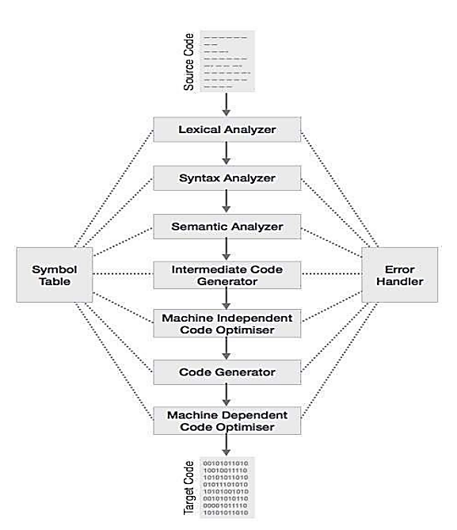

**Lexical Analysis:**

The word “lexical” in the traditional sense means “pertaining to words”. In terms of programming languages, words are objects like variable names, numbers, keywords etc. Such words are traditionally called tokens.

Lexical analysis is the first phase of compiler which is also termed as scanning. A token is a sequence of characters that represent lexical unit, which matches with the pattern, such as keywords, operators, identifiers etc. Source program is scanned to read the stream of characters and those characters are grouped to form a sequence called lexemes which produces token as output.

A lexical analyzer, or lexer for short, will as its input take a string of individual letters and divide this string into tokens. Additionally, it will filter out whatever separates the tokens (the so-called white-space), i.e., lay-out characters (spaces, newlines, etc.) and comments.

Tokens, Patterns and Lexemes Token​:

It is a valid sequence of characters which are given by lexeme. In a programming language, keywords, constant, identifiers, numbers, operators and punctuations symbols are possible tokens to be identified. Example of tokens:

● Type token (id, number, real, . . . )

● Punctuation tokens (IF, void, return, . . . )

● Alphabetic tokens (keywords)

***Pattern:*** A pattern describes a rule that must be matched by sequence of characters (lexemes) to form a token. It can be defined by regular expressions or grammar rules.

For example - [A-Za-z][A-Za-z_0-9]*

***Lexeme​:*** A lexeme is a sequence of characters that matches the pattern for a token i.e., instance of a token. Eg: c=a+b*5;

The sequence of tokens produced by lexical analyzer helps the parser in analyzing the syntax of programming languages.

***Role of a Lexical Analyzer:***

A lexical analyzer performs the following tasks:

● Reads the source program, scans the input characters, group them into lexemes and produce the token as output.

● Enters the identified token into the symbol table.

● Strips out white spaces and comments from source program.

● Correlates error messages with the source program i.e., displays error message with its occurrence by specifying the line number.

● Expands the macros if it is found in the source program.

***Need of Lexical Analyzer:***

● Simplicity of design of compiler - ​The removal of white spaces and comments enables the syntax analyzer for efficient syntactic constructs.

● Compiler efficiency is improved - ​Specialized buffering techniques for reading

characters speed up the compiler process.

● Compiler portability is enhanced

***Lexical Errors:***

A character sequence that cannot be scanned into any valid token is a lexical error. Lexical errors are uncommon, but they still must be handled by a scanner. Usually, a lexical error is caused by the appearance of some illegal character, mostly at the beginning of a token.

Lexical Analyzer also generates errors in the following cases:

1) Unterminated String​: When the right number of inverted commas are not provided.

2) Nested Comments​: Nested comments are not supported.

3) Unmatched Parenthesis​: If there are missing parenthesis, an error message is generated.

4) Invalid Identifier​: If the entered identifier does not match the identifier forming rules, an error message is displayed.

***FLEX:***

The scanner performs lexical analysis of a certain program. It reads the source program as a sequence of characters and recognizes "larger" textual units called tokens.

FLEX stands for Fast Lexical Analyzer Generator. It is a tool for generating scanners. Instead of

writing a scanner from scratch, you only need to identify the vocabulary of a certain language, write a specification of patterns using regular expressions (e.g. DIGIT [0-9]), and FLEX will construct a scanner for you. FLEX is generally used in the manner depicted here:

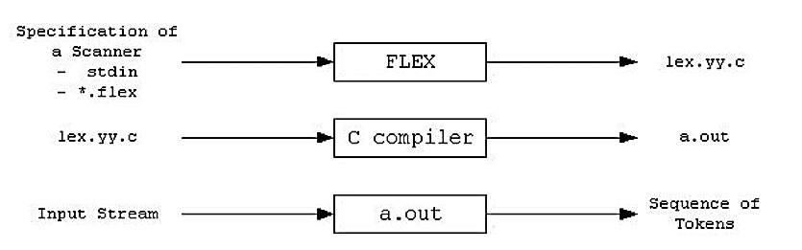

First, FLEX reads a specification of a scanner either from an input file *.lex, or from standard input, and it generates as output a C source file lex.yy.c. Then, lex.yy.c is compiled and linked with the "-lfl" library to produce an executable a.out. Finally, a.out analyzes its input stream and transforms it into a sequence of tokens.

● *.lex​ is in the form of pairs of regular expressions and C code.

● lex.yy.c​ defines a routine yylex() that uses the specification to recognize tokens.

● a.out​ is actually the scanner.

These programs perform character parsing and tokenizing via the use of a deterministic finite automaton (DFA). A DFA is a theoretical machine accepting regular languages. These machines are a subset of the collection of Turing machines. DFAs are equivalent to read-only right moving Turing machines. The syntax is based on the use of regular expressions.

***Format Of the Flex File:***

The flex input file consists of three sections, separated by a line with just `%%' in it: definitions %% rules %% user code The definitions​ section contains declarations of simple name​ definitions to simplify the scanner specification, and declarations of start conditions​, which are explained in a later section. Name definitions have the form:

*name definition*

The "name" is a word beginning with a letter or an underscore ('_') followed by zero or more letters, digits, '_', or '-' (dash). The definition is taken to begin at the first non-whitespace character following the name and continuing to the end of the line. The definition can subsequently be referred to using "{name}", which will expand to "(definition)". For example,

*DIGIT [0-9]*

*ID [a-z][a-z0-9]\**

defines "DIGIT" to be a regular expression which matches a single digit, and "ID" to be a regular expression which matches a letter followed by zero-or-more letters-or-digits. A subsequent reference to

*{DIGIT}+"."{DIGIT}\**

is identical to

*([0-9])+"."([0-9])\**

and matches one-or-more digits followed by a '.' followed by zero-or-more digits.

The rules section of the flex input contains a series of rules of the form:

*pattern action*

where the pattern must be unintended and the action must begin on the same line.

Finally, the user code section is simply copied to `lex.yy.c' verbatim. It is used for companion routines which call or are called by the scanner. The presence of this section is optional; if it is missing, the second `%%' in the input file may be skipped, too.

In the definitions and rules sections, any indented text or text enclosed in `%{' and `%}' is copied verbatim to the output (with the `%{}''s removed). The `%{}''s must appear unintended on lines by themselves. In the rules section, any indented or %{} text appearing before the first rule may be used to declare variables which are local to the scanning routine and (after the declarations) code which is to be executed whenever the scanning routine is entered. Other indented or %{} text in the rule section is still copied to the output, but its meaning is not well-defined and it may well cause compile-time errors. In the definitions section (but not in the rules section), an unintended comment (i.e., a line beginning with "/*") is also copied verbatim to the output up to the next "*/".

**Implementation:**

*scanner.l:*

This is the lex program that contains various regular expressions for all the specific actions that are to be carried out by a lexical analyzer. This file is converted to lex.yy.c​ which is compiled to get the executable a.out

Code:

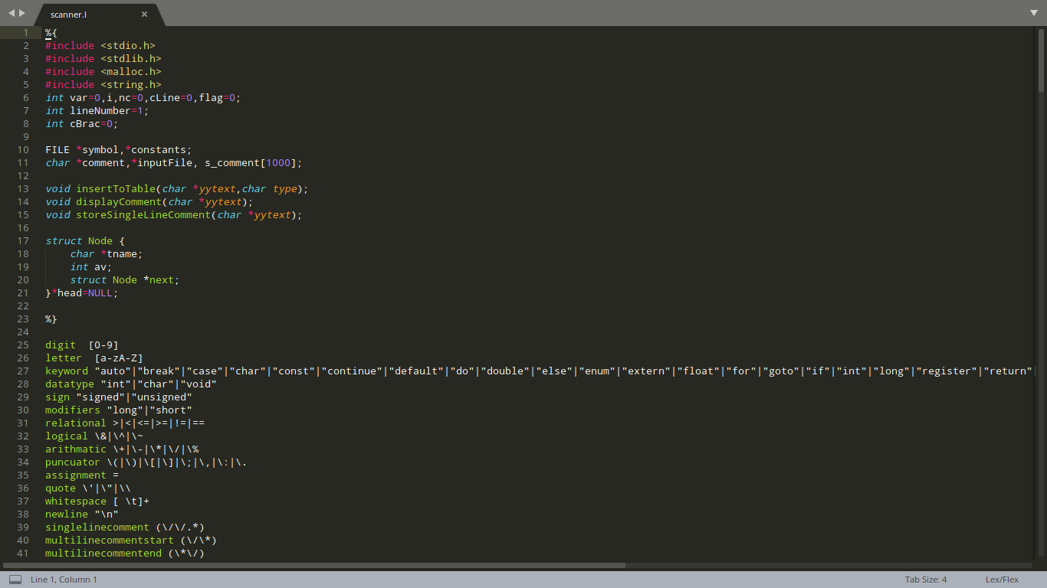

Fig. 1

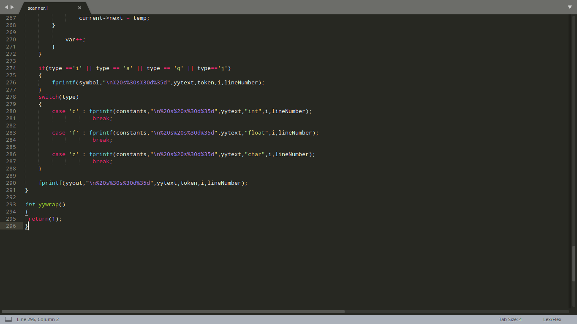

Fig. 2

*Input.c*

This is the C source program for which the lexical analysis is done. Based on this, we generate the Symbol and Constants Table.

Code:

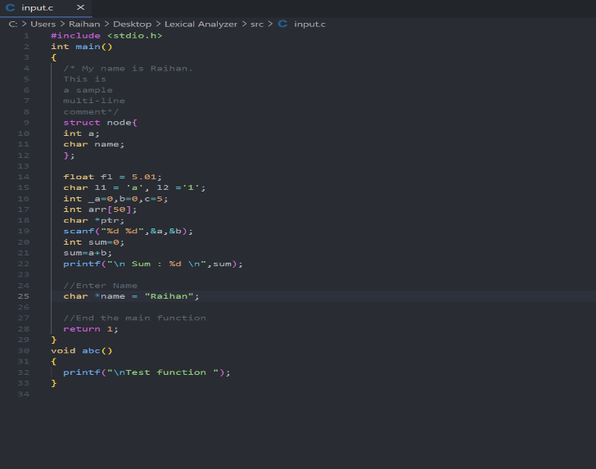

**Execution Of Code:**

The lex code can be executed by the following commands :

● flex<filename1>

● cc lex.yy.c

● ./a.out <filenmae2>

Where <filename1> is the lex program (here scanner.l​)

<filenmae2>is the C source program for which Lexical Analysis is done. (here input.c​)

**Output:**

*symbolTable.txt :*

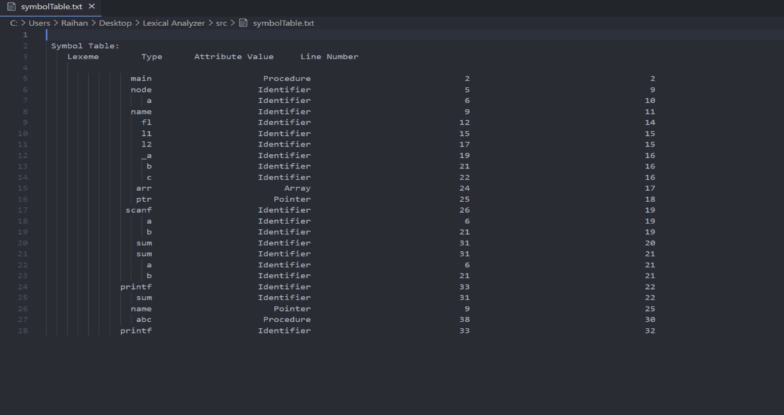

*constantTable.txt*

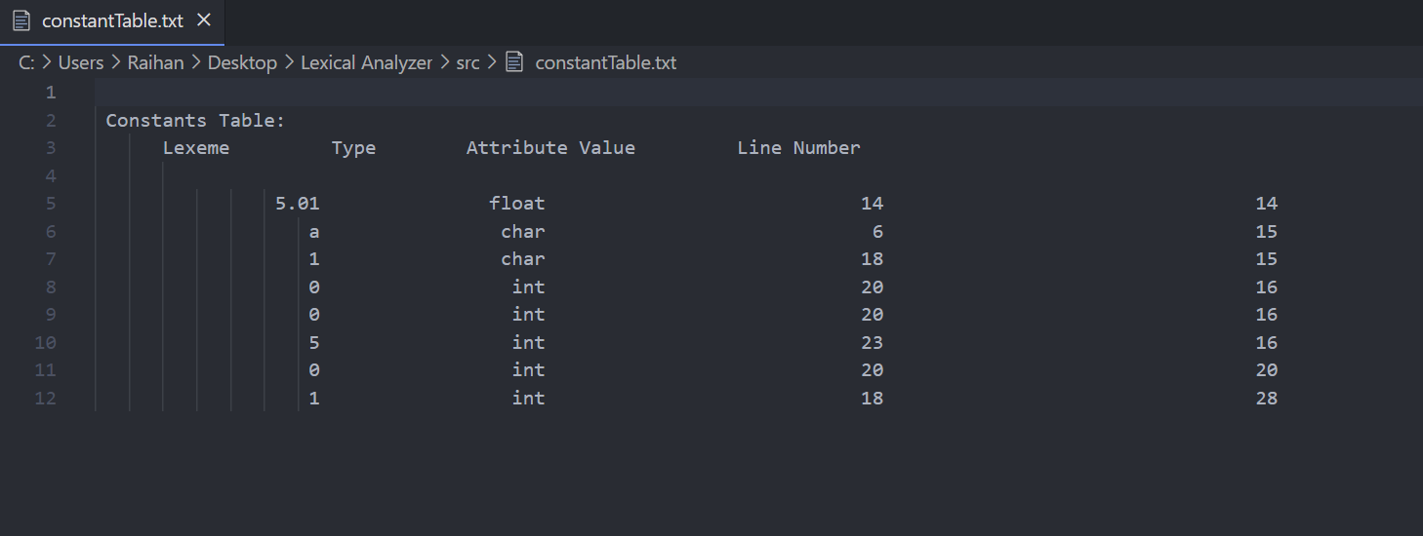

*parsedTable.txt*

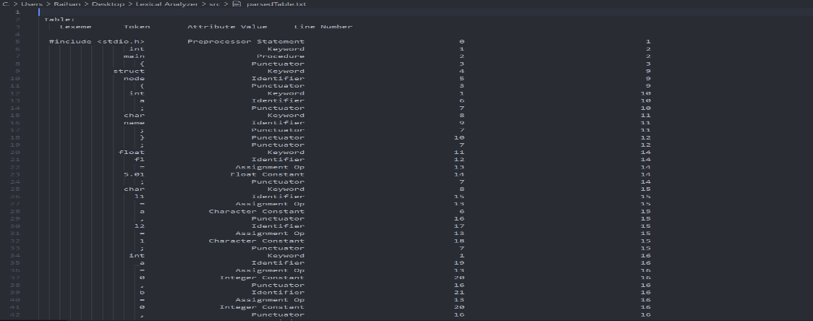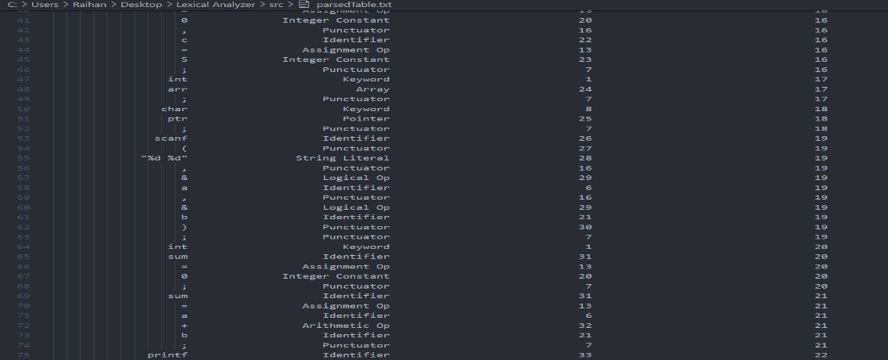

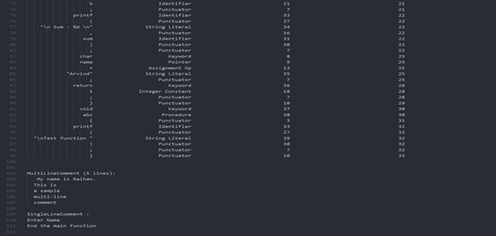

**Test Cases:**

|  |  |  |  |
| --- | --- | --- | --- |
| Test Case Filename | Test Case Type | Code | Status |
| Case1.c | Pre-Processor statements | #include<stdio.h> #define count 10 | Passed |
| Case2.c | Constants Keywords Punctuators Variables | int a=25;  char c='h';  char arr1[10]="hello";  char arr2[10]="hello; | Passed  Constants:  Integer: 25  Character: ’h’  String: “Hello”  Key Words: int char  Identifiers:  a c arr1 arr2  Invalid String “hello |
| Case3.c | Relational Operators  Logical Operators  Arithmetic Operators | int a=1,b=2,c=3,d; a++;  --b; c=a+b; d+=a; d=a||b; c=a%b; d=a++c; a=c+/c; d=a>b; | Passed  Relational: >  Logical: ||  Arithmetic: + - / % \ |
| Case4.c | Single Line Comments  Multi Line Comments | // single line comment  /// this is valid comment  /* this is  a multi line comment */  /* this is  a /* nested */ comment */  invalid comment */  /* invalid comment | Passed  Passed  Passed  Passed Error  Passed Error  Passed Error |
| Case5.c | Control Statements Looping Statements | int a=1,b=2,c=10;  if(a>b){ printf("\nInside if");  } else{  printf("\nInside else"); }  if(b>a){ if(b<c){  printf("\nNested if "); }  }  for(int i=1;i<=10;i++){  printf("\nIteration %d",i); }  for(int i=0;i<10;i++){ for(int J=0;J<20;J++){  printf("\nNestedloop "); }  } | Passed  Keywords If else for  Datatype Int  Identifiers J a b c i  Procedures :  printf () |
| Case6.c | Function Declaration | struct student{ int a; char c;  };  union teacher{ int q;  };  void abc(){ printf("\nHello World"); }  void main(){ student *S; teacher *T; | Passed  Procedures :  main() abc() printf()  Identifiers :  Student teacher |

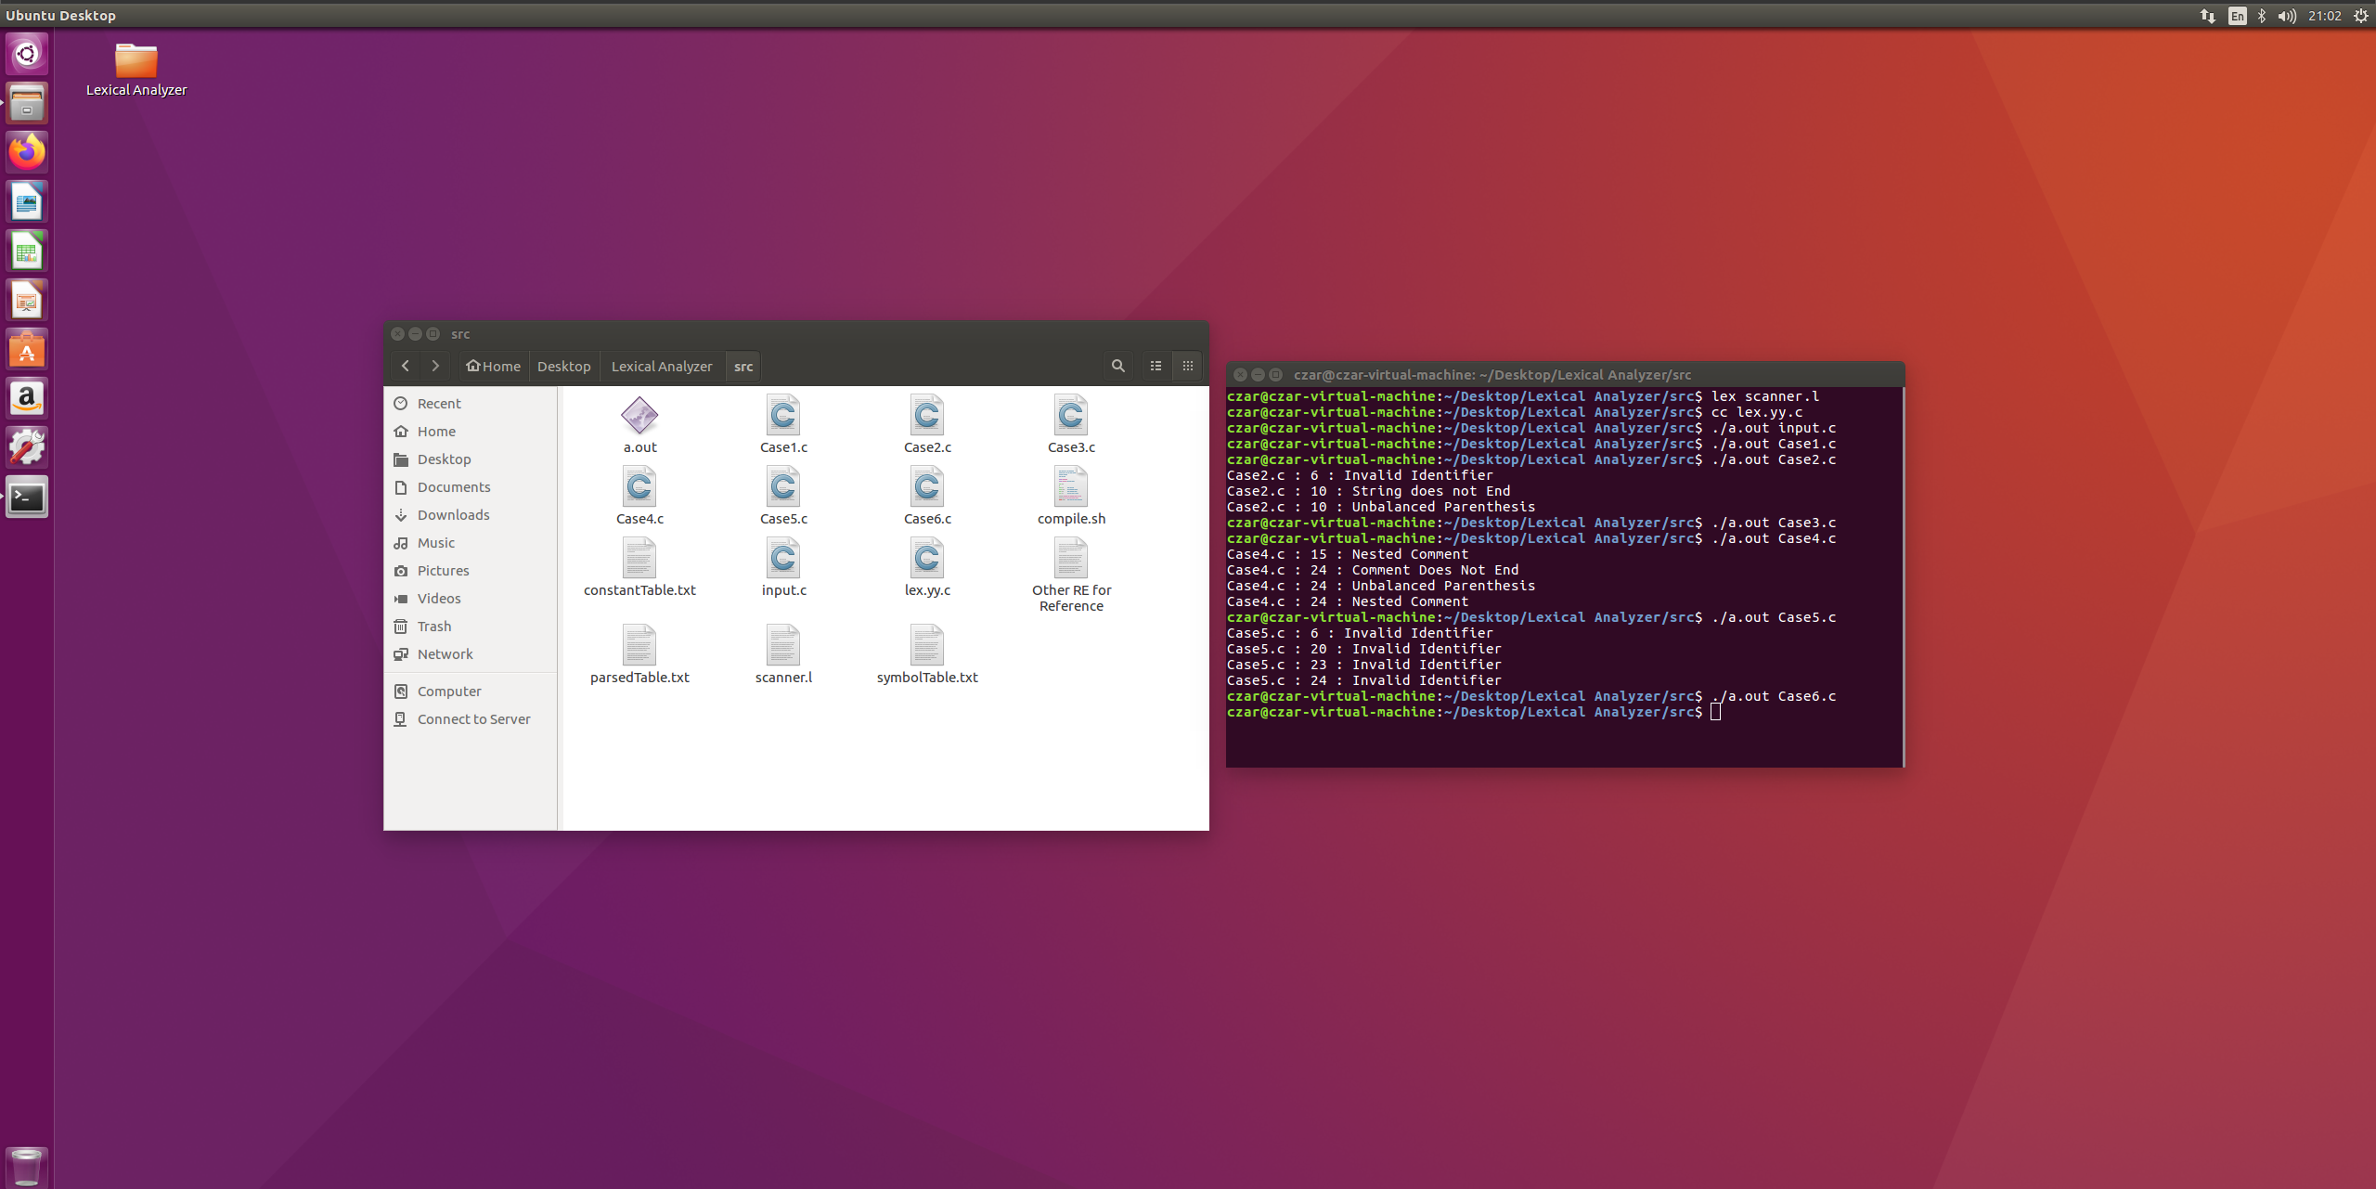

**Remarks:**

We have made a scanner for C Programming Language. The following features have been taken care of:

1) Identification of Keywords, Identifiers, Operators (Relational, Logical and Arithmetic), Punctuators, Constants (Integer, Character and Float) and String Literals.

2) Arrays

3) Pointers

4) Single and Multi-Line Comments

5) Data Types (int, float and char) with modifiers (unsigned and signed) and types (short, long).

6) Procedures

The following lexical errors have been handled:

1) Nested Comments

2) Invalid Identifiers

3) Invalid String

4) Balancing of Parentheses

**PARSER FOR C**

**Introduction:**

When an input string (source code or a program in some language) is given to a compiler, the compiler processes it in several phases, starting from lexical analysis (scans the input and divides it into tokens) to target code generation. The aim of this phase of a compiler is to implement a parser for C language. The lexical analyzer generated in the first phase reads the source program and generates tokens that are given as input to the parser which then creates a syntax tree in accordance with the grammar, consequently leading to the generation of intermediate code that is fed into the synthesis phase, to obtain the correct, equivalent machine level code. We have seen that a lexical analyzer can identify tokens with the help of regular expressions and pattern rules. But a lexical analyzer cannot check the syntax of a given sentence due to the limitations of the regular expressions. Regular expressions cannot check balancing tokens, such as parenthesis. Therefore, this phase uses context-free grammar (CFG), which is recognized by push-down automata.

**Syntax Analysis:**

Syntax Analysis or Parsing is the second phase, i.e. after lexical analysis. A syntax analyzer or parser takes the input from a lexical analyzer in the form of token streams. The parser analyzes the source code (token stream) against the production rules to detect any errors in the code. It checks the syntactic structure of the given input, i.e. whether the given input is in the correct syntax (of the language in which the input has been written) or not. It does so by building a data structure, called a Parse tree or Syntax tree. The parse tree is constructed by using the predefined Grammar of the language and the input string. If the given input string can be produced with the help of the syntax tree (in the derivation process), the input string is found to be in the correct syntax. The Grammar for a Language consists of Production rules.

**Context-Free Grammar:**

A context-free grammar has four components:

● A set of non-terminals (V). Non-terminals are syntactic variables that denote sets of strings. The non-terminals define sets of strings that help define the language generated by the grammar.

● A set of tokens, known as terminal symbols (Σ). Terminals are the basic symbols from which strings are formed.

● A set of productions (P). The productions of a grammar specify the manner in which the terminals and non-terminals can be combined to form strings. Each production consists of a non-terminal called the left side of the production, an arrow, and a sequence of tokens and/or on- terminals, called the right side of the production.

● One of the non-terminals is designated as the start symbol (S); from where the production

begins.

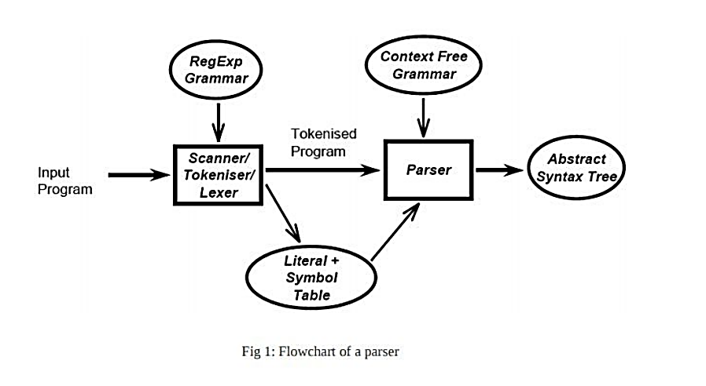

The strings are derived from the start symbol by repeatedly replacing a non-terminal (initially the start symbol) by the right side of a production, for that non-terminal.

**Parse Tree:**

A parse tree is a graphical depiction of a derivation. It is convenient to see how strings are derived from the start symbol. The start symbol of the derivation becomes the root of the parse tree. Consider the following example with the given Production rules and Input String.

Input string ​: id + id * id

Production rules:

● E → E + E

● E → E * E

● E → id

The left-most derivation is:

● E → E * E

● E → E + E * E

● E → id + E * E

● E → id + id * E

● E → id + id * id

The parse tree for the given input string is:

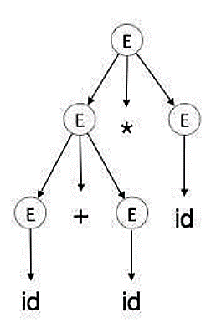

In a parse tree:

● All leaf nodes are terminals.

● All interior nodes are non-terminals.

● In-order traversal gives original input string. A parse tree depicts associativity and precedence of operators. The deepest sub-tree is traversed first, therefore the operator in that sub-tree gets precedence over the operator which is in the parent nodes.

**Yacc Script:**

YACC stands for Yet Another Compiler-Compiler. It is a parser generator for LALR (1) grammars. Given a description of the grammar, it generates a C source for the parser. The input is a file that contains the grammar description with a formalism similar to the BNF (Backus-Naur Form) notation for language specification:

● Non-terminal symbols - lowercase identifiers 4

○ Expr, stmt

● Terminal symbols - uppercase identifiers or single characters

○ INTEGER, FLOAT, IF, WHILE, ‘;’, ‘.’

● Grammar rules (Production rules) ○ expr: expr ‘+’ expr | expr ‘*’ expr ; E→E+E|E*E

Yacc provides a general tool for imposing structure on the input to a computer program. The Yacc user prepares a specification of the input process; this includes rules describing the input structure, code to be invoked when these rules are recognized, and a low-level routine to do the basic input. Yacc then generates a function to control the input process. This function, called a parser, calls the user-supplied low-level input routine (the lexical analyzer) to pick up the basic items (called tokens) from the input stream. These tokens are organized according to the input structure rules, called grammar rules; when one of these rules has been recognized, then user code supplied for this rule, an action, is invoked; actions have the ability to return values and make use of the values of other actions.

**Basic Specifications:**

Names refer to either tokens or nonterminal symbols. Yacc requires token names to be declared as such. Every specification file consists of three sections: the declarations, (grammar) rules, and programs. The sections are separated by double percent ``%%'' marks. (The percent ``%'' is generally used in Yacc specifications as an escape character.)

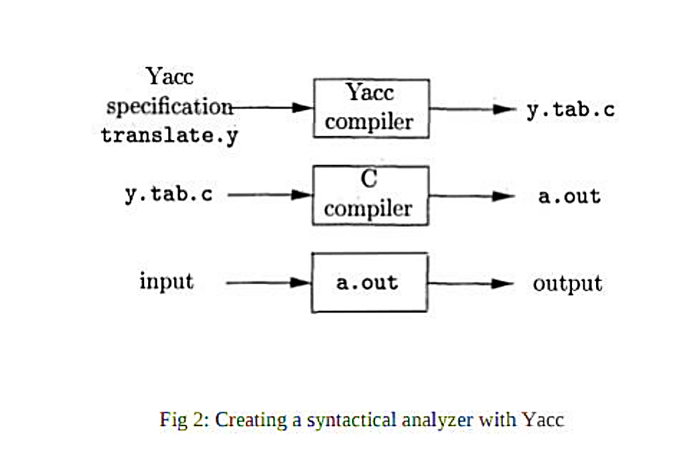

In other words, a full specification file looks like:

declarations

%%

rules

%% programs

The declaration section may be empty. Moreover, if the programs section is omitted, the second %% mark may be omitted also; thus, the smallest legal Yacc specification is

%%

rules

The rules section is made up of one or more grammar rules. A grammar rule has the form:

A: BODY; A represents a nonterminal name, and BODY represents a sequence of zero or more names and literals.

**Actions:**

With each grammar rule, the user may associate actions to be performed each time the rule is recognized in the input process. These actions may return values, and may obtain the values returned by previous actions. Moreover, the lexical analyzer can return values for tokens, if desired. An action is an arbitrary C statement, and as such can do input and output, call subprograms, and alter external vectors and variables. An action is specified by one or more statements, enclosed in curly braces “{“and “}”.

**How the Parser Works:**

Yacc turns the specification file into a C program, which parses the input according to the specification given. The parser produced by Yacc consists of a finite state machine with a stack. The parser is also capable of reading and remembering the next input token (called the lookahead token). The current state is always the one on the top of the stack. A move of the parser is done as:

1. Based on current state, the parser decides whether it needs a lookahead token to decide what action should be done; if it needs and does not have one, it calls yylex to obtain the next token.
2. Using the current state, and the lookahead token if needed, the parser decides on its next action, and carries it out. This may result in states being pushed onto the stack, or popped off of the stack, and in the lookahead token being processed or left alone.

**Source Code:**

*Lexical Analyzer:* This is the lex program that contains regular expressions and returns whatever tokens are required.

*Syntax Analyzer:* This is the main parser code, a yacc file which contains the declarations, rules and programs and defines the actions which should be taken for various cases.

**Execution Of the Code:**

The following is a shell script to automate the compilation and execution of the parser.

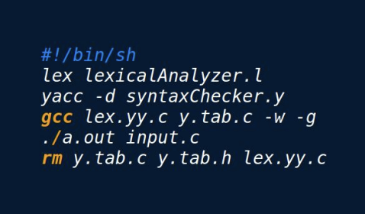

**Implementation:**

The implementation is as follows:

● Firstly, a file is created with a “. y” extension, which represents a yacc file. The file created here is “syntaxChecker.y ​”.

● The file, like all yacc files, contains three main sections: Declarations, Rules, and Programs.

● The declaration section contains the structure for each entries of symbol table that is identifier name, data type and attribute values (in our case, line number)

● Also, the declaration section contains all the pointer used in lexical phase to track each token that is each pointer from “lexicalAnalyzer.l​” is imported here as extern type and used accordingly to raise lexical errors as well as syntactical errors using the production rules for each token

● Also, declaration contains function declaration for symbol table and constant table management ( that is void makList(char *, char, int )

● The Rules section contains the various grammatical rules that are to be followed while parsing.

● The Programs section is where the yyparse() and the yyerror() functions are called,in order to generate the error message at the line where the syntax error has occurred.

● The Program section makes symbol table (“symblTable.txt​”) and constant table (“constantTable.txt​”) for each node of the link list struct tokenList

● If a production rule contains identifier or constants makeList( )​ function will be invoked with respective type as ‘v’ or ‘c’ along with line number accordingly linked list for them is maintained

● void makeList(char *tokenName , char tokenType , int lineNumber ) ​will add the identifier and constants accordingly by using linked list if an identifier is again came which is already there then it’s line number is appended to the first entry hence no duplicate entry for each identifier in symbol table

● Once the file is made, it is run using the shell script by giving the following command: ./compile.sh

**Simple Input:**

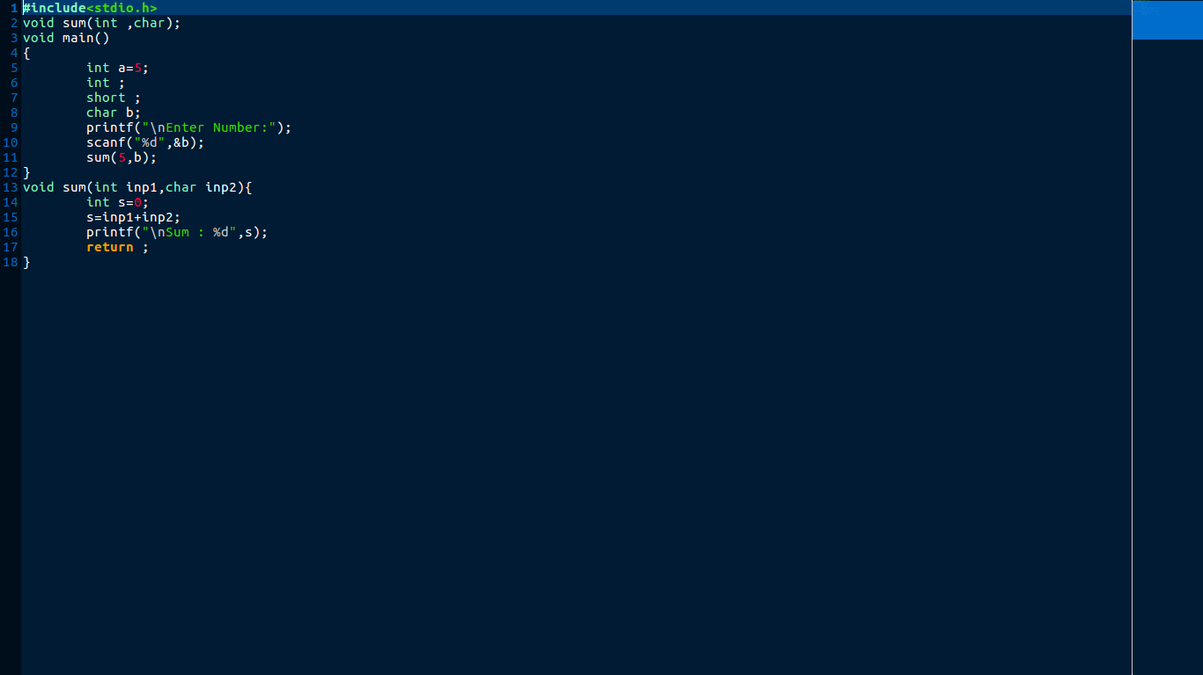

**Simple Output:**

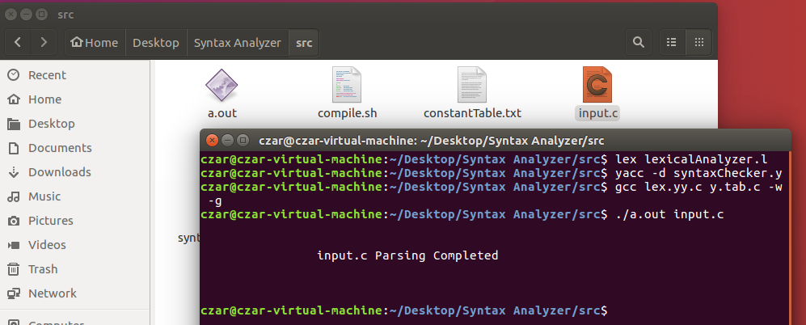

**Symbol Table:**

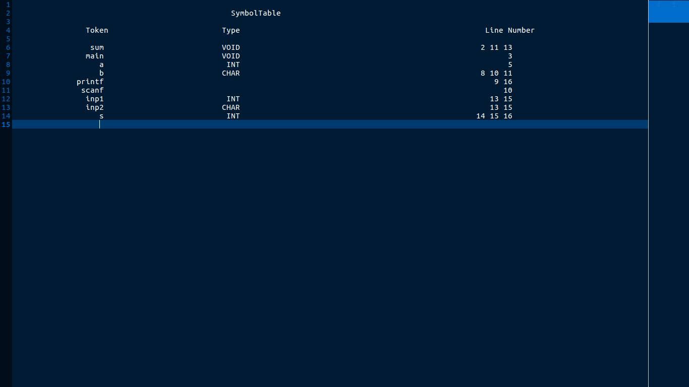

**Constant Table:**

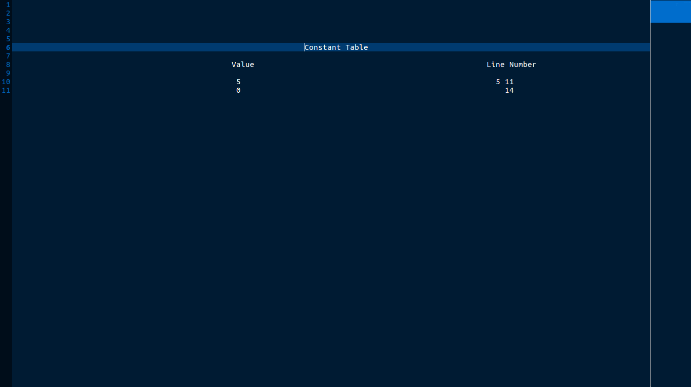

**Test Case Evaluation:**

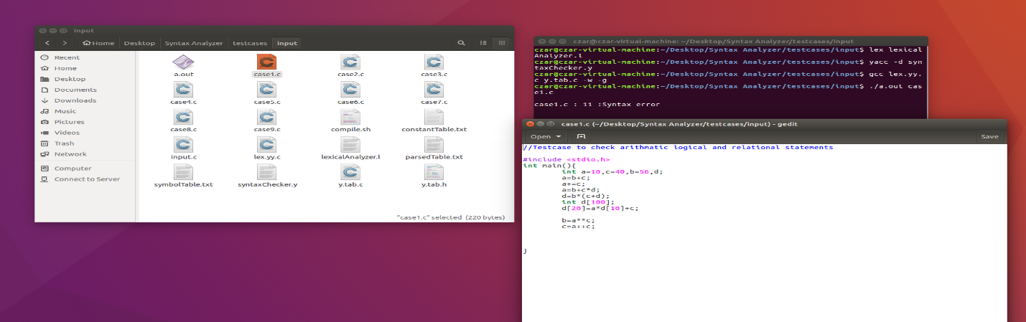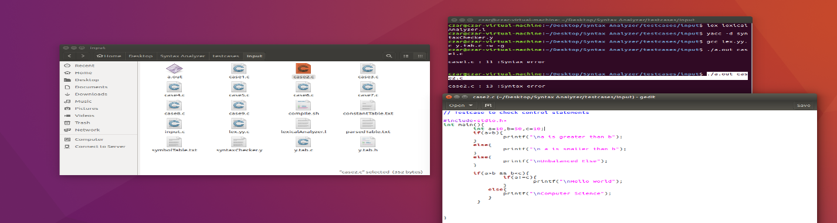

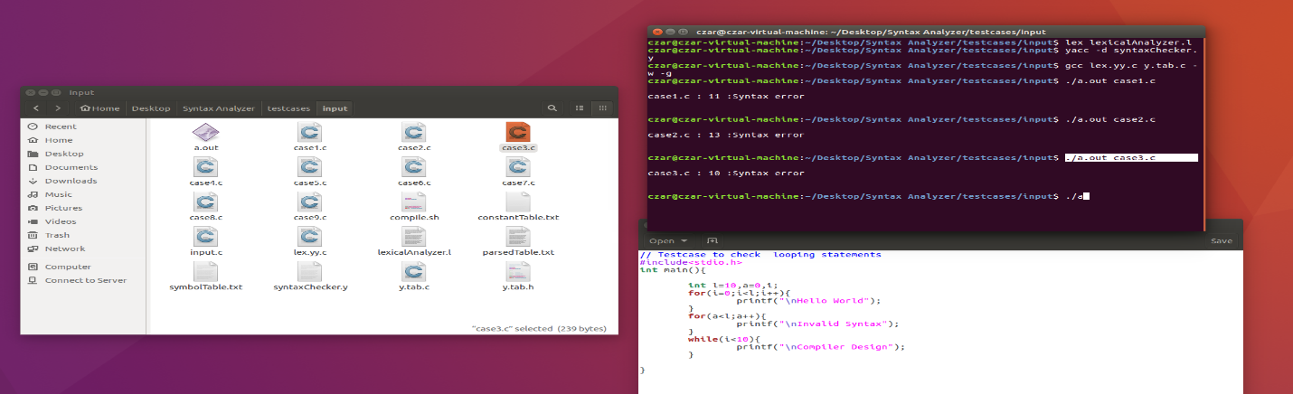

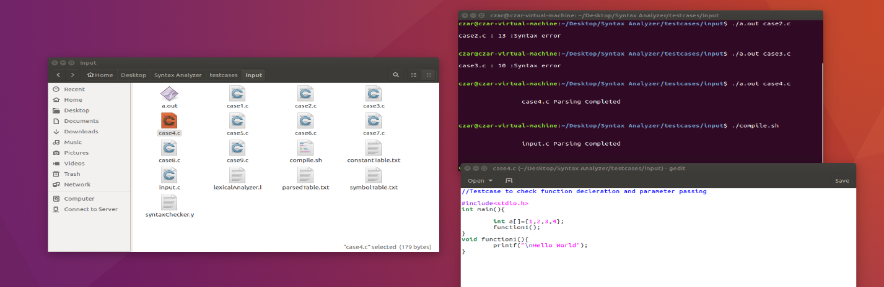

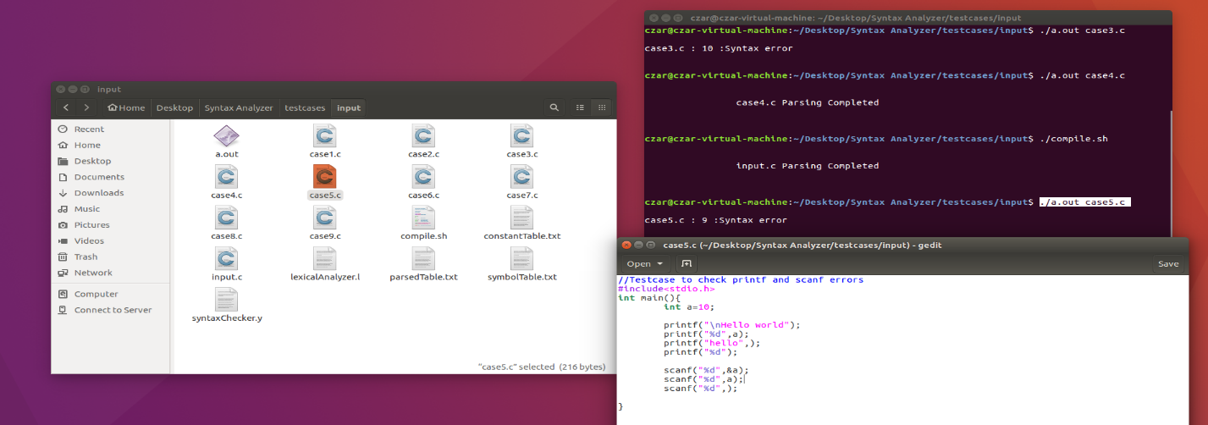

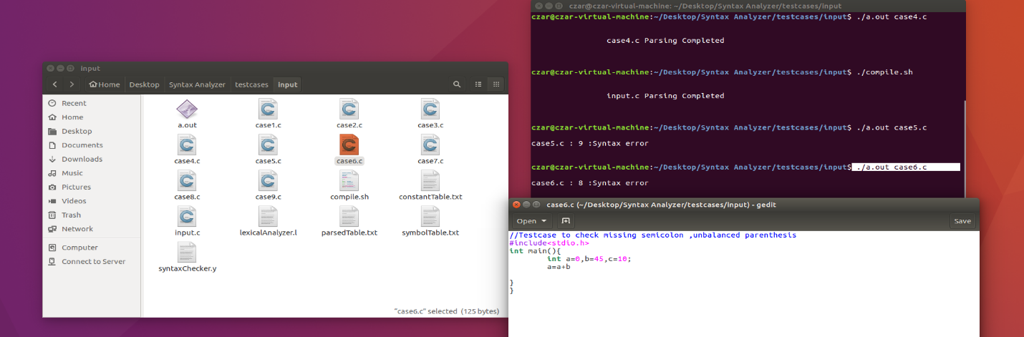

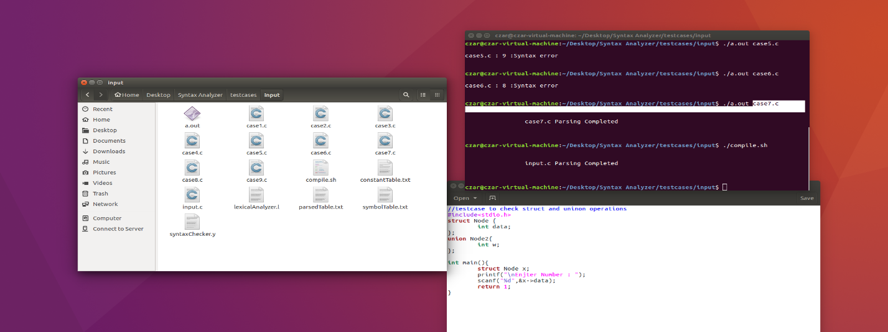

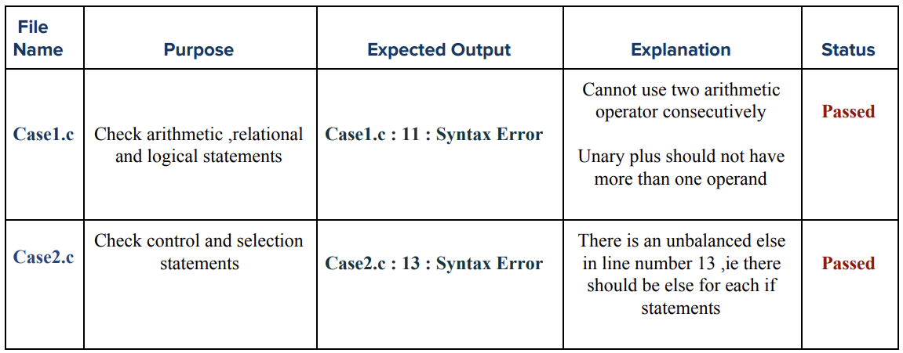

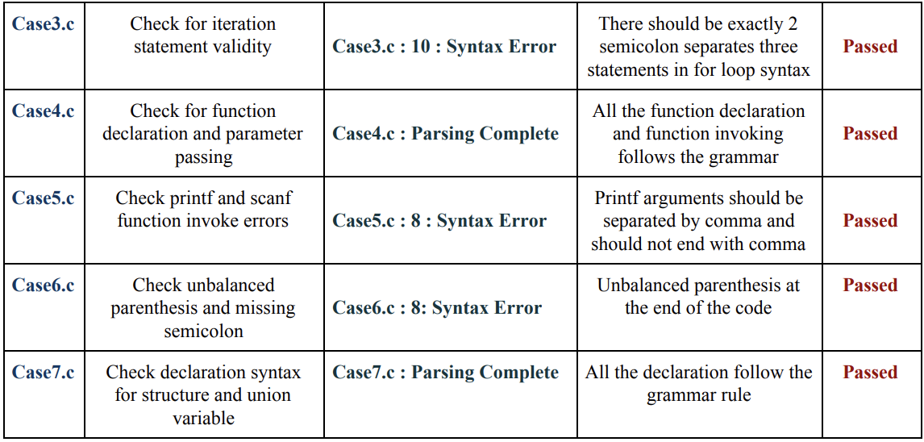

**Conclusion:**

After the second phase of this project, we have successfully implemented and added a Syntactic Analyzer/Parser to the C Compiler. This takes in the stream of tokens generated by the Lexical Analyzer implemented in the first phase as input.

For the output, it displays syntax errors along with their corresponding line number. Symbol table and Constant table have also been added. The following list of features have been included in this phase:

1. Syntax checking for Arithmetic, Logical and Relational Expressions

2. IF, IF...ELSE and Nested IF statements

3. Validation of Unary Operators

4. Validation of all loops

a. FOR

b. WHILE

c. DO...WHILE

5. Proper declaration of functions and parameter passing

6. Array declaration

7. Structure and Union

8. Scanf and Printf errors

9. Missing semicolon at the end of statements

10. Unbalanced Parentheses

**SEMANTIC CHECKER FOR C**

**Introduction:**

A parser constructs parse trees in the syntax analysis phase. The plain parse-tree constructed in that phase is generally of no use for a compiler, as it does not carry any information of how to evaluate the tree. The productions of context-free grammar, which makes the rules of the language, do not accommodate how to interpret them. For example,

E → E + T

The above CFG production has no semantic rule associated with it, and it cannot help in making

any sense of the production. Parsing only verifies that the program consists of tokens arranged in a syntactically valid combination.

**Semantic analysis:**

Semantics of a language provide meaning to its constructs, like tokens and syntax structure. Semantics help interpret symbols, their types, and their relations with each other. Semantic analysis judges whether the syntax structure constructed in the source program derives any meaning or not. CFG + semantic rules = Syntax Directed Definitions

For example:

int a = “value”; should not issue an error in lexical and syntax analysis phase, as it is lexically and structurally correct, but it should generate a semantic error as the type of the assignment differs. These rules are set by the grammar of the language and evaluated in semantic analysis.

Semantic analysis is the task of ensuring that the declarations and statements of a program are semantically correct, i.e , that their meaning is clear and consistent with the way in which control structures and data types are supposed to be used. Semantic analysis is not a separate module within a compiler. It is usually a collection of procedures called at appropriate times by the parser as the grammar requires it. Implementing the semantic actions is conceptually simpler in recursive descent parsing because they are simply added to the recursive procedures. Implementing the semantic actions in a table - action driven LL(1) parser requires the addition of a third type of variable to the productions and the necessary software routines to process it.

Part of semantic analysis is producing some sort of representation of the program, either object code or an intermediate representation of the program. One - pass compilers will generate object code without using an intermediate representation; code generation is part of the semantic actions performed during parsing. Other compilers will produce an intermediate representation during semantic analysis; most often it will be an abstract syntax tree or quadruples. Semantic analysis typically involves:

● *Type checking* - Data types are used in a manner that is consistent with their definition (i. e., only with compatible data types, only with operations that are defined for them, etc.)

● *Label Checking* - Labels references in a program must exist.

● *Flow control checks* - Control structures must be used in their proper fashion (no GOTOs into a FORTRAN DO statement, no breaks outside a loop or switch statement, etc.)

● Array-bound Checking - Variables being used as an array index should be within the

bounds of the array.

● Scope Resolution - We need to determine what identifiers are accessible at different

points in the program. Abstract syntax trees have one enormous advantage over other intermediate representations: they can be “decorated” , i.e., each node on the AST can have their attributes saved in the AST nodes, which can simplify the task of type checking as the parsing process continues.

**Attribute grammar:**

An attribute is a property whose value is assigned to a grammar symbol. Attribute computation functions (or semantic functions) are associated with the productions of a grammar and are used to compute the values of an attribute. An attribute grammar is an extension to a context - free grammar that is used to describe features of a programming language that cannot be described in BNF or can only be described in BNF with great difficulty. Each attribute has well-defined domain of values, such as integer, float, character, string, and expressions. Attribute grammar is a medium to provide semantics to the context-free grammar and it can help specify the syntax and semantics of a programming language. Attribute grammar (when viewed as a parse-tree) can pass values or information among the nodes of a tree.

E → E + T { E.value = E.value + T.value }

The right part of the CFG contains the semantic rules that specify how the grammar should be interpreted. Here, the values of non-terminals E and T are added together and the result is copied

to the non-terminal E. Semantic attributes may be assigned to their values from their domain at the time of parsing and evaluated at the time of assignment or conditions. Based on the way the attributes get their values, they can be broadly divided into two categories:

● Synthesized attributes - These attributes get values from the attribute values of their child nodes. Synthesized attributes never take values from their parent nodes or any sibling nodes. For example,

S → ABC

If S is taking values from its child nodes (A, B, C), then it is said to be a synthesized attribute, as the values of ABC are synthesized to S.

● Inherited attributes - In contrast to synthesized attributes, inherited attributes can take values from parent and/or siblings. For example,

S → ABC

A can get values from S, B and C. B can take values from S, A, and C. Likewise, C can take values from S, A, and B.

**Syntax Directed Translation:**

Parser uses a CFG(Context-free-Grammar) to validate the input string and produce output for next phase of the compiler. Output could be either a parse tree or abstract syntax tree. Now to interleave semantic analysis with syntax analysis phase of the compiler, we use Syntax Directed Translation. Syntax Directed Translation are augmented rules to the grammar that facilitate semantic analysis. SDT involves passing information bottom-up and/or top-down the parse tree in form of attributes attached to the nodes. Syntax directed translation rules use :

1) lexical values of nodes,

2) constants

3) attributes associated to the non-terminals in their definitions.

For example,

E -> E+T { E.val = E.val + T.val } PR#1

E -> T { E.val = T.val } PR#2

T -> T*F { T.val = T.val * F.val } PR#3

T -> F { T.val = F.val } PR#4

F -> INTLIT { F.val = INTLIT.lexval } PR#5

Suppose we take the first SDT augmented to [ E -> E+T ] production rule. The translation rule in consideration has val as attribute for both the non-terminals – E & T. Right hand side of the translation rule corresponds to attribute values of right side nodes of the production rule and vice-versa.

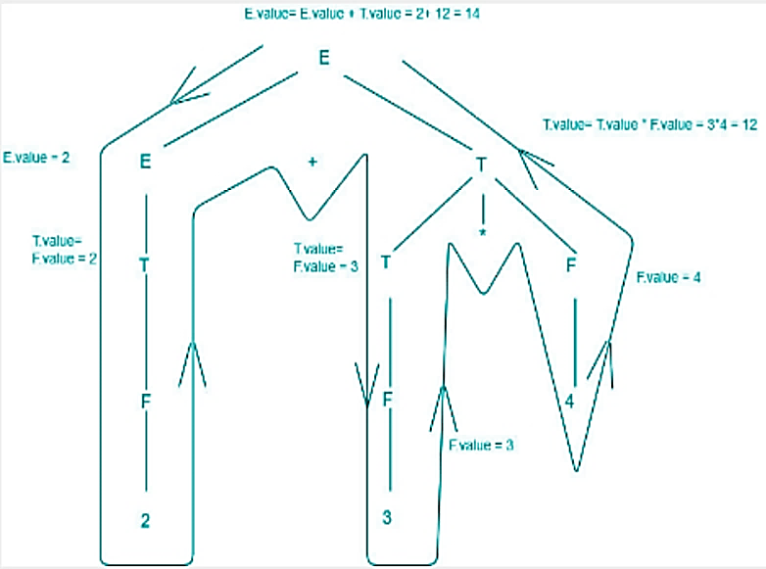

Above diagram shows how semantic analysis could happen. The flow of information happens

bottom-up and all the children attributes are computed before parents.

● S-attributed SDT - If an SDT uses only synthesized attributes, it is called as S-attributed SDT. These attributes are evaluated using S-attributed SDTs that have their semantic actions written after the production (right hand side). Attributes in S-attributed SDTs are evaluated in bottom-up parsing, as the values of the parent nodes depend upon the values of the child nodes.

● L-attributed SDT - This form of SDT uses both synthesized and inherited attributes with restriction of not taking values from right siblings. In L-attributed SDTs, a non-terminal can get values from its parent, child, and sibling nodes. Attributes in L-attributed SDTs are evaluated by depth-first and left-to-right parsing manner.

**Implementation:**

*Scope:* Implemented using stack. Variable called scope is used which is initially set to 0. Increment and push to stack when opening brace is found. On finding closing brace, pop out the last element from stack. This will assign unique value to each block of code. Stack as a whole contains the scope-id, which is unique. In case of functions, the passed parameters are also part of the function block, therefore increment the scope variable when you encounter.

*Declaration Checking:* To check whether an identifier is declared or not, check the symbol table corresponding to the value having scope-id equal to the current stack (which gives scope-id of the matched identifier). If not present, then undeclared.

*Type Checking:* When you encounter the type, use a global variable called flag which will indicate the type. For example, flag = 1 for int. When you encounter an assignment statement the current flag and the stored type value of the identifier has to match which is found out by consulting the symbol table.

*Re-declaration Checking:* When inserting a variable, check if the variable with same name exists with same scope-id. This is taken care by hashing the variable name along with the scope-id. Redeclaration is checked every time we insert identifier into the symbol table.

*Array Dimension:* When you encounter array declaration, pass the array dimension number into the symbol table. This makes sure that it's only positive integer integer.

*Symbol Table.* It contains fields:

1. Name: identifier name.

2. Token: token is constant or identifier.

3. Type: type of identifier whether int, float, void etc.

4. Scope: Scope could be global, function.

5. Scope-id: Unique value given to each block of code.

6. Function-id: Unique for each function declaration

All the semantic actions are written in semantic.h file, including maintaining symbol table. Necessary functions are called from syntaxChecker.y and lexicalAnalyzer.l for performing semantic actions and to report semantic error if any. Source code for all the files are included below.

**Source Code:**

*Lexical Analyzer:* This is the lex program that contains regular expressions and returns whatever tokens are required.

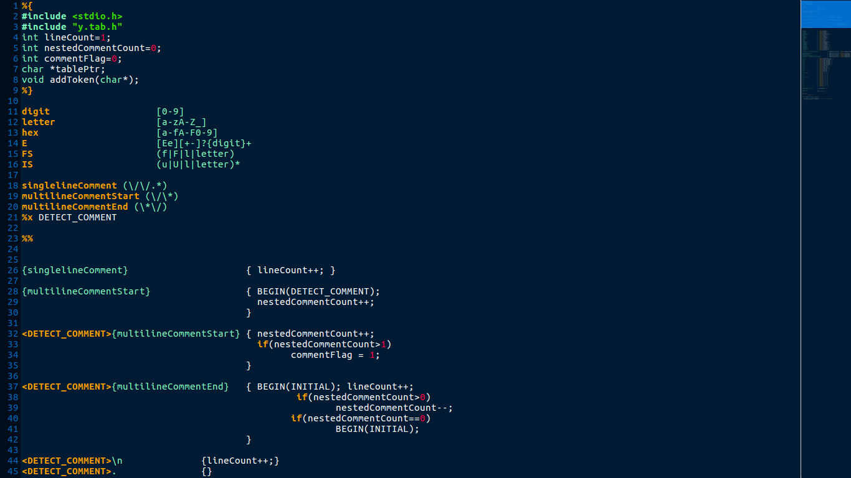

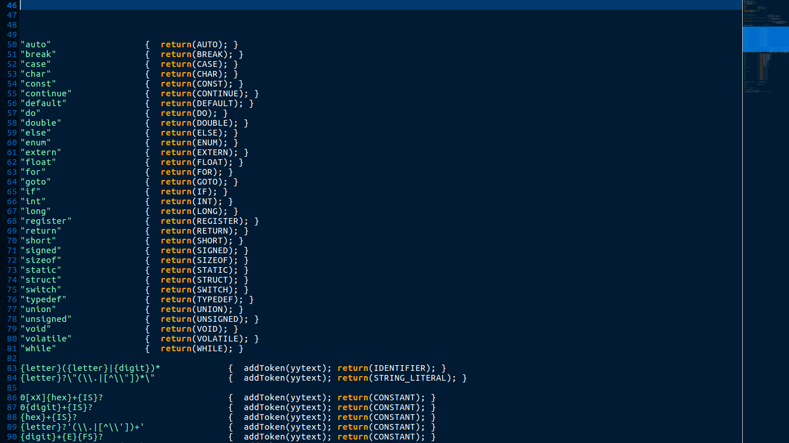

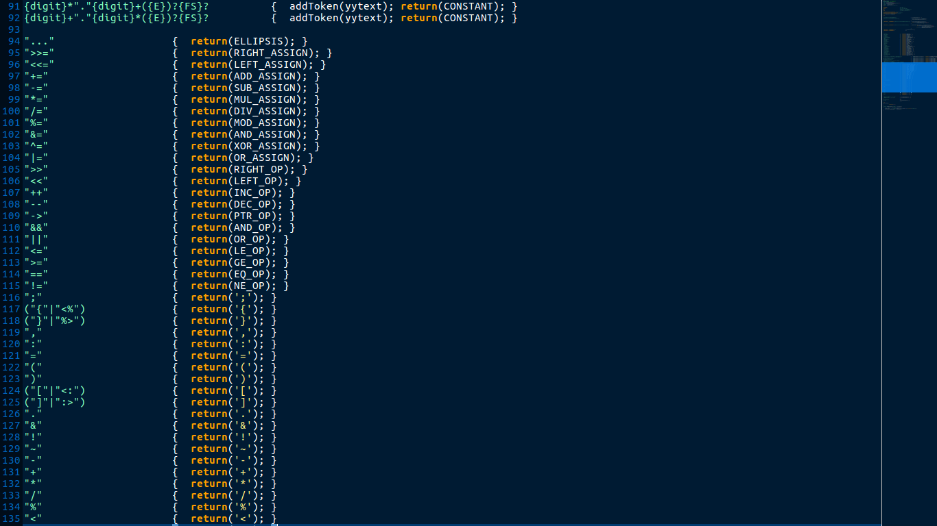

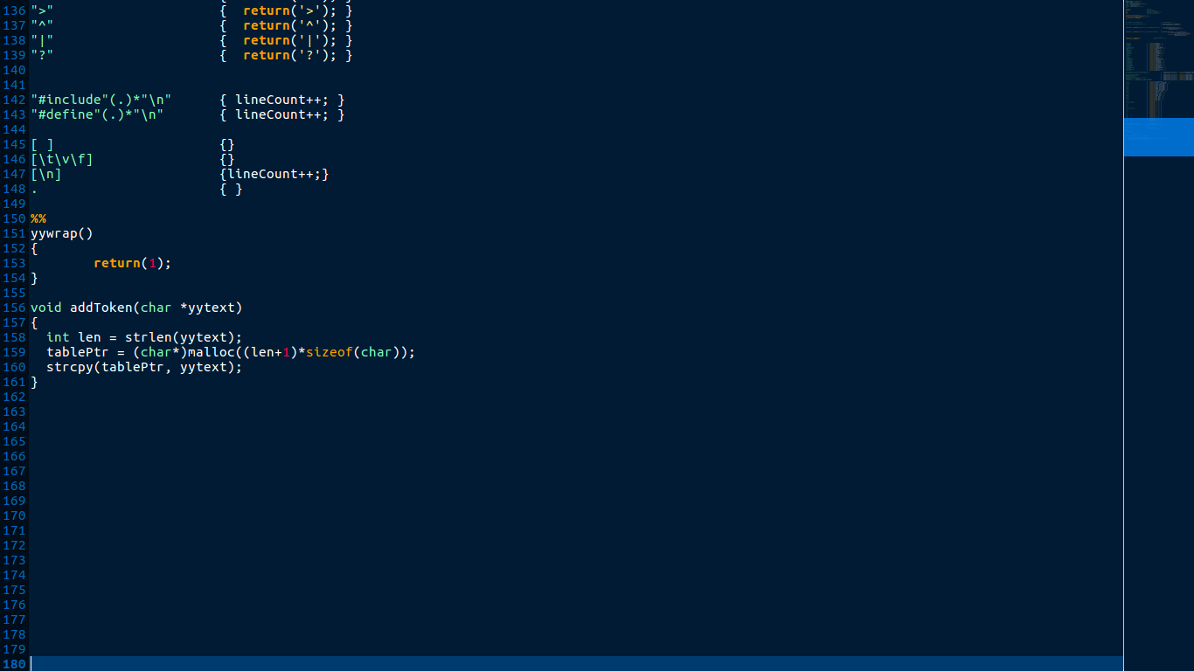

*Syntax Analyzer:* This is the main parser code, a yacc file which contains the declarations, rules and programs and defines the actions which should be taken for various cases.

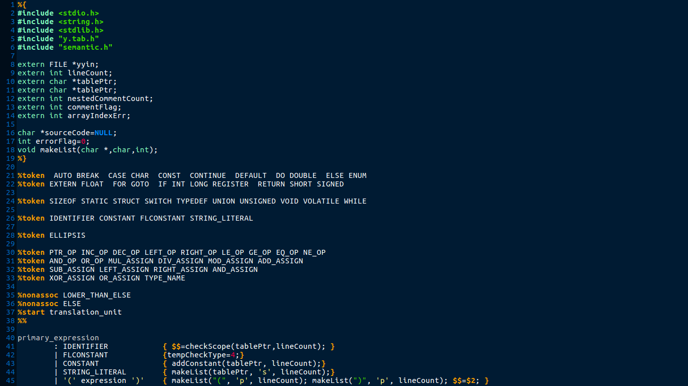

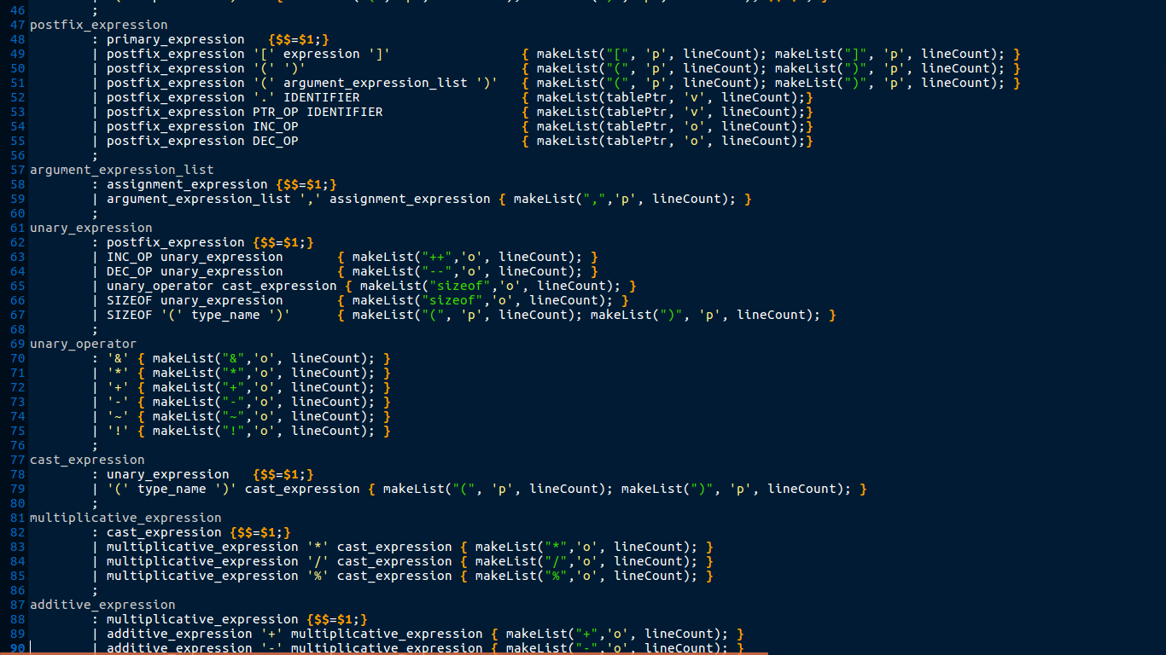

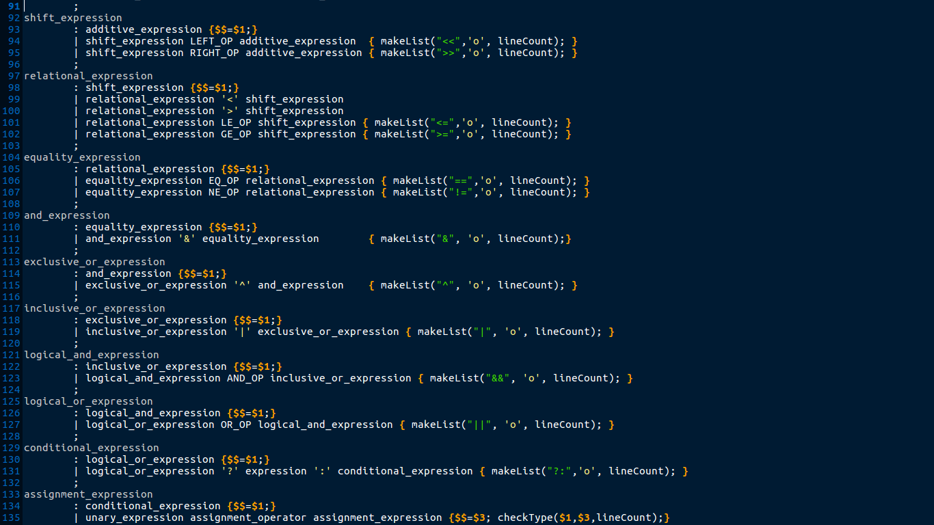

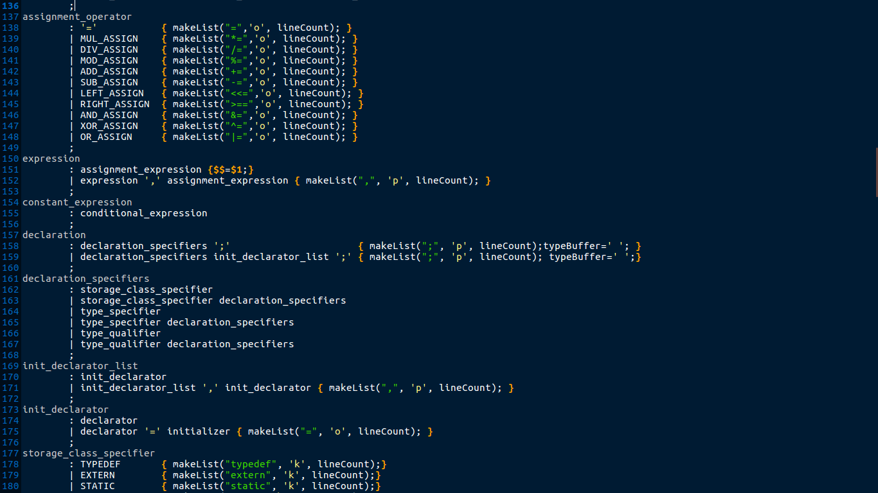

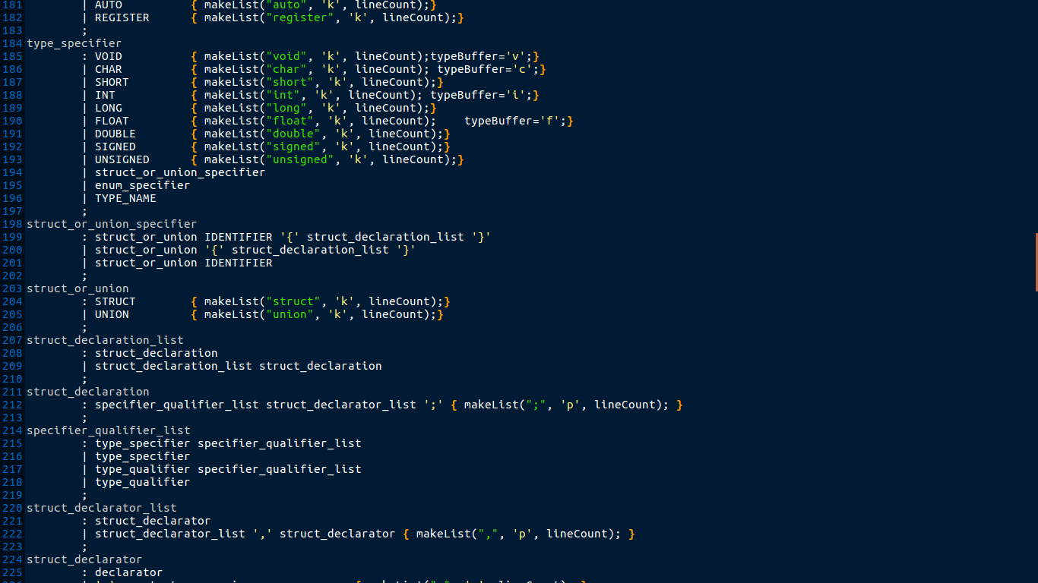

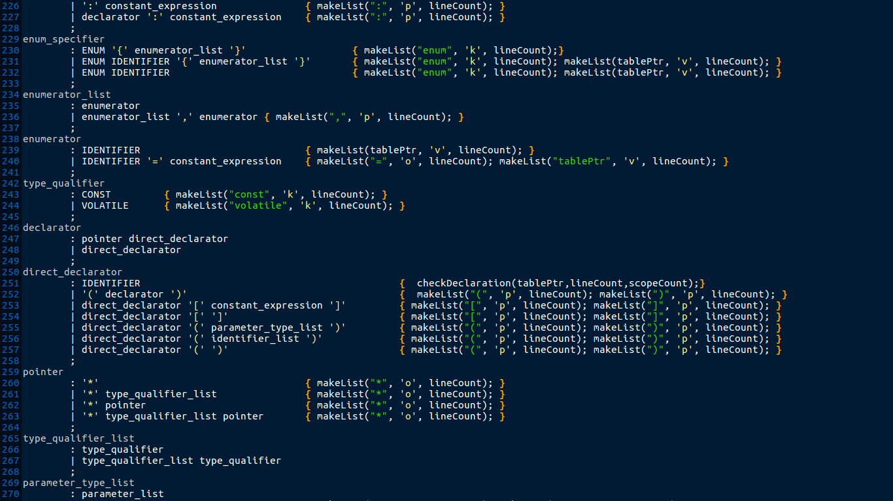

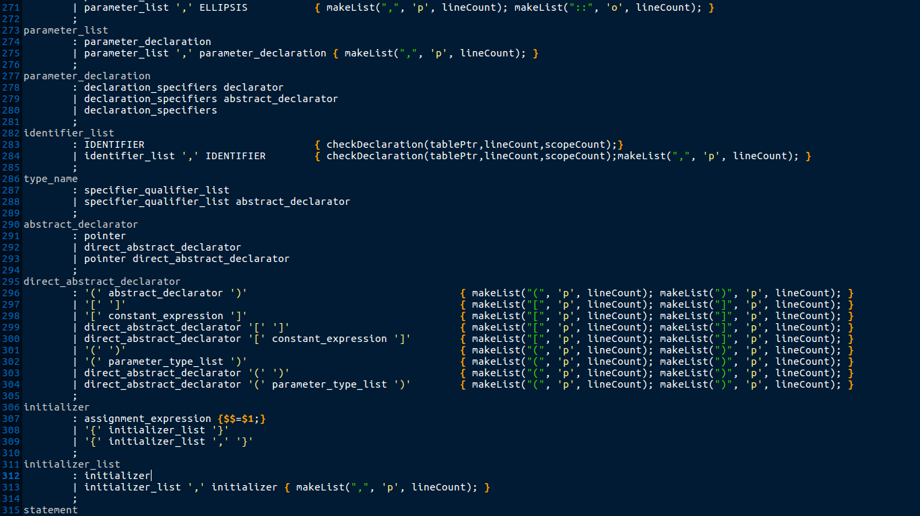

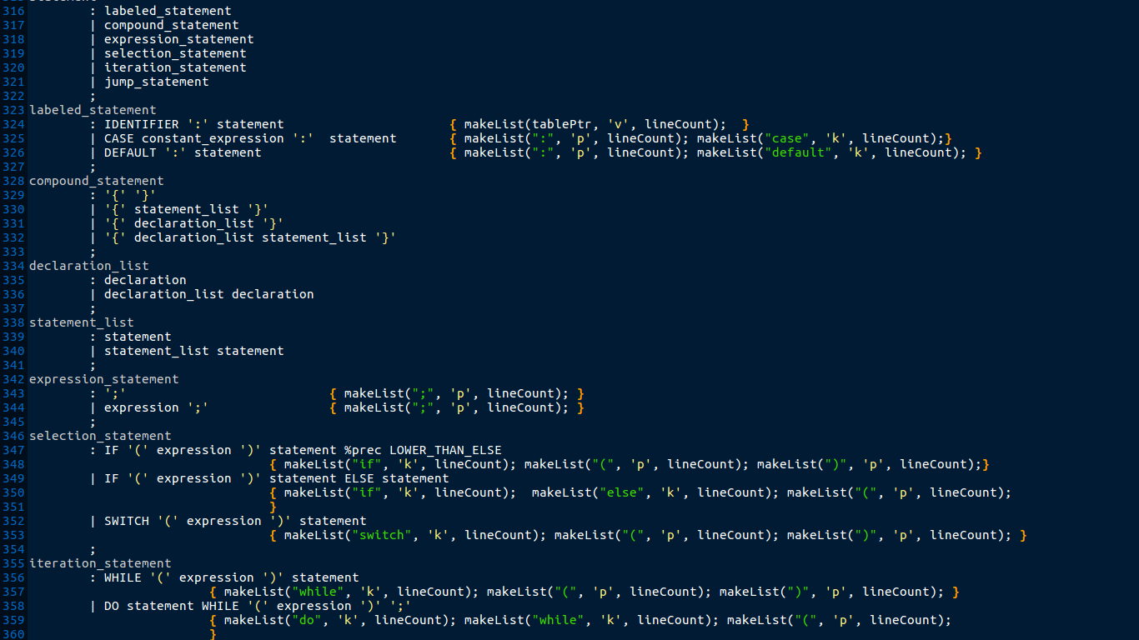

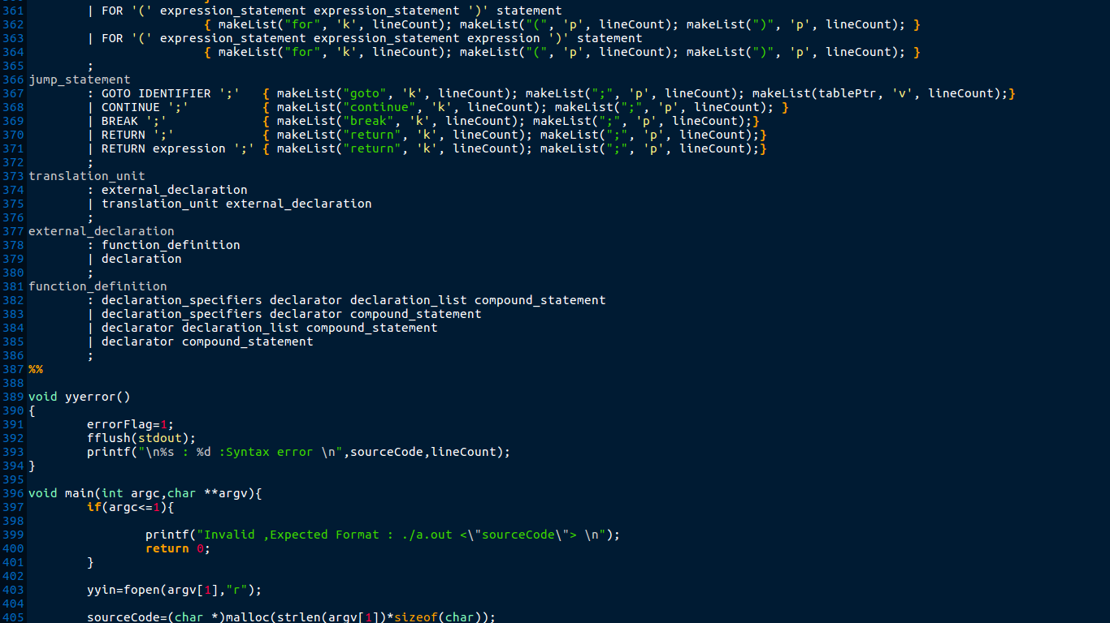

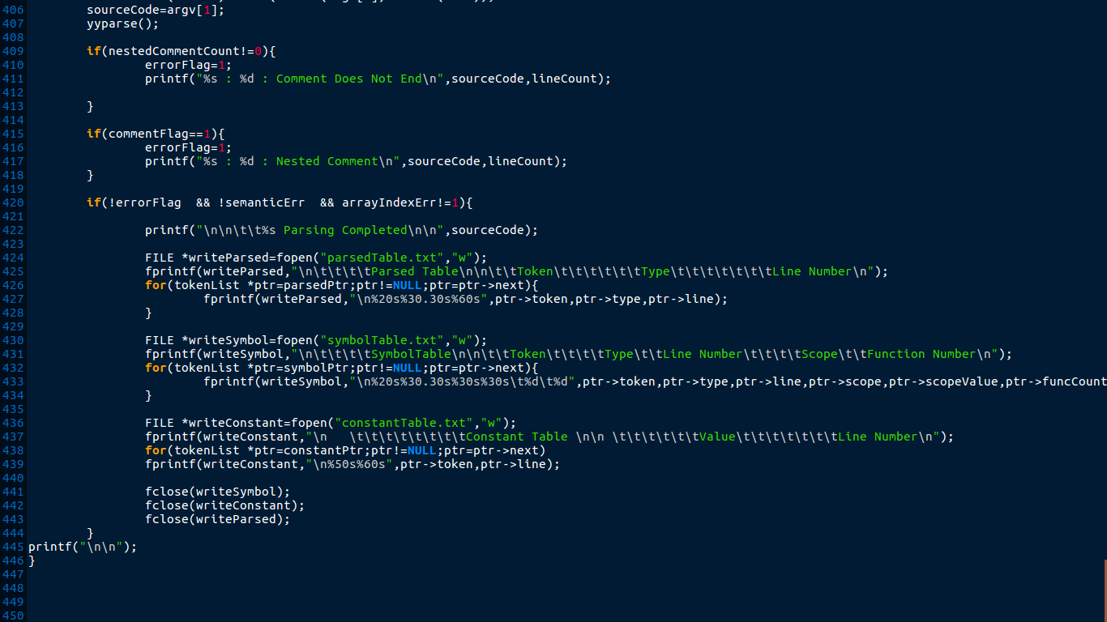

*Semantic Analyzer:* This is the semantic phase code, a c header file which contains the function that is called by different production rule in parser phase and taken care of symbol table entry.

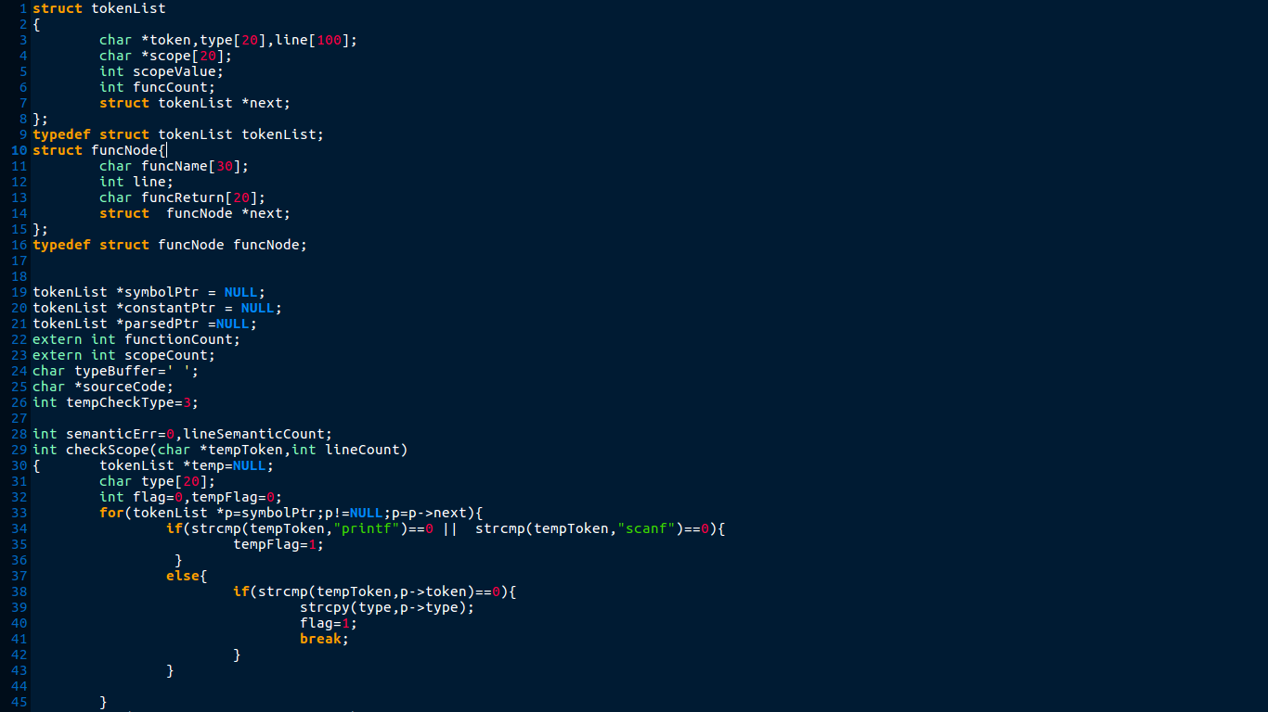

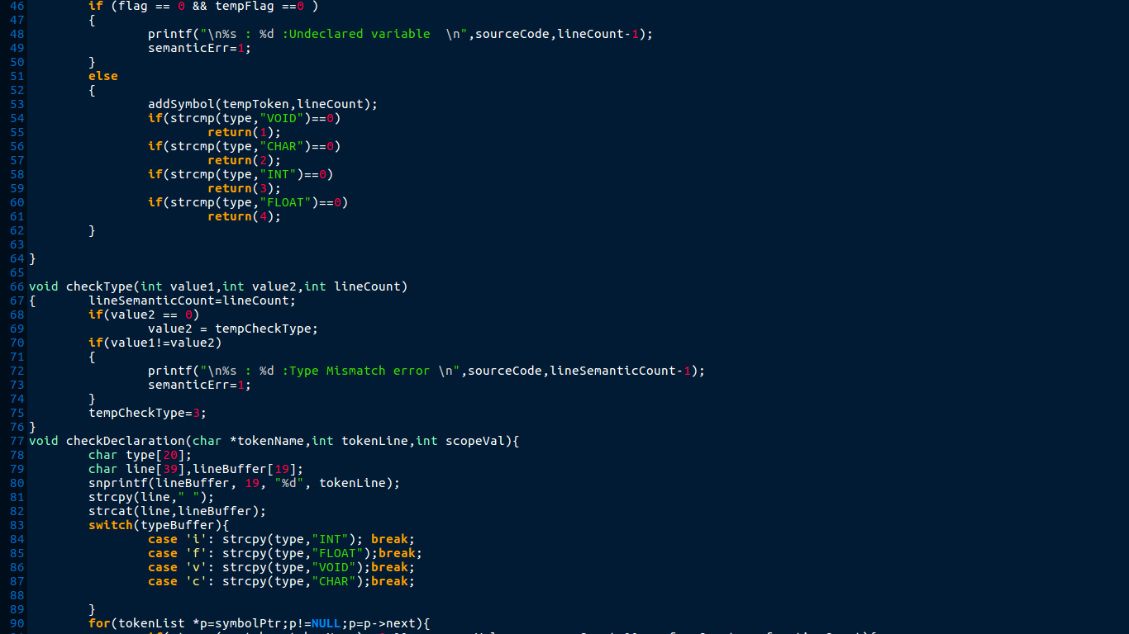

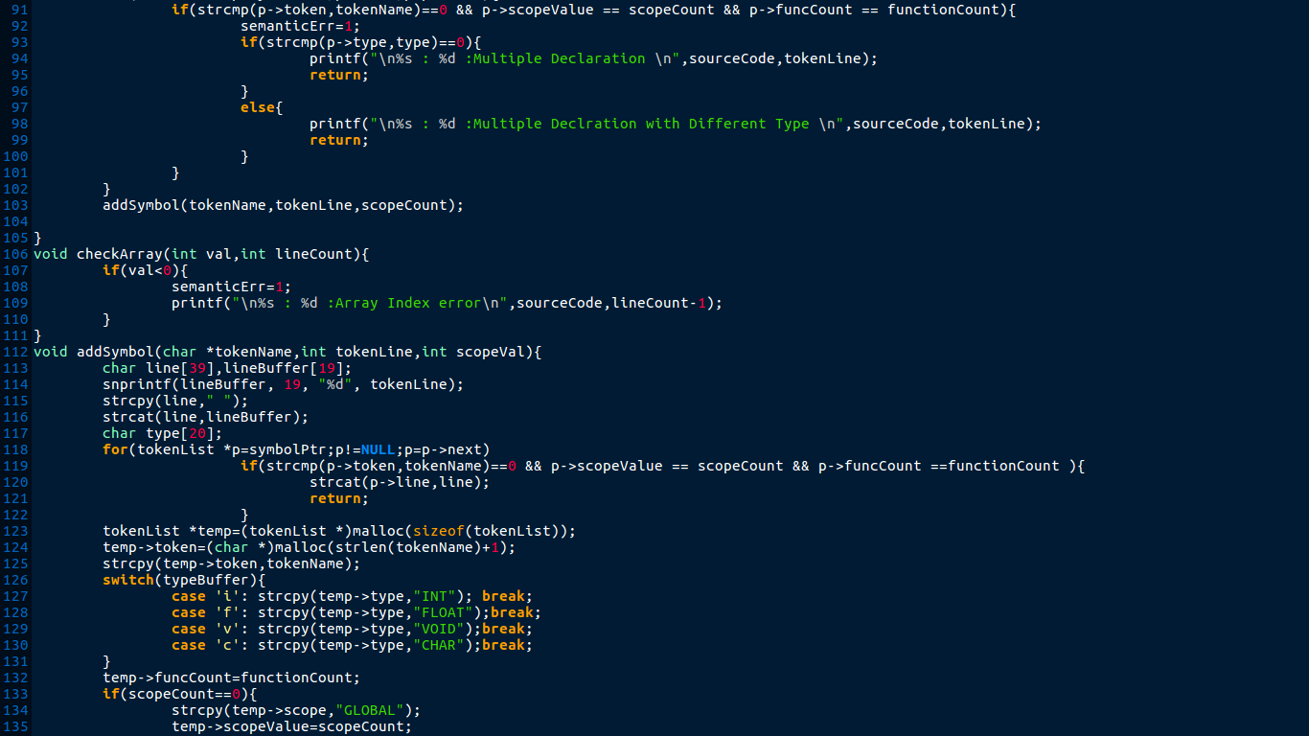

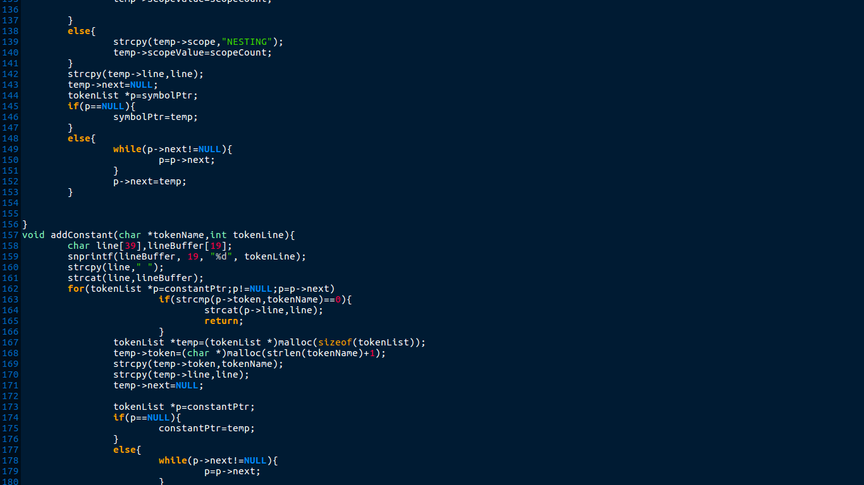

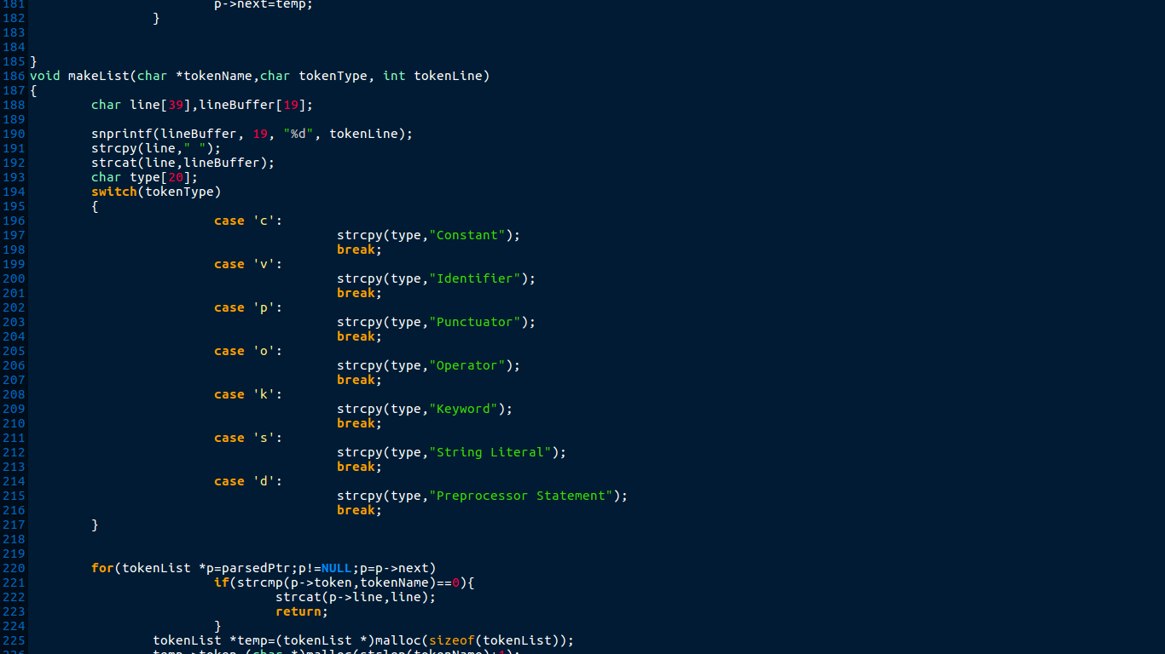

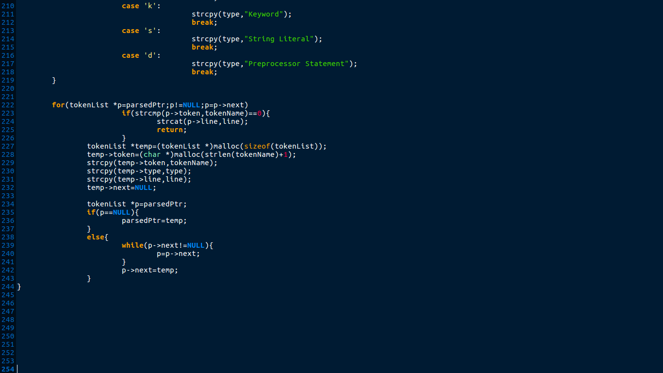

**Execution Of the Code:**

The following is a shell script to automate the compilation and execution of the mini compiler consist of lexical, syntax and semantic phases. There is sample input source code given. Execution of the same is done and output is shown as sample output and respective symbol table is generated.

Input:

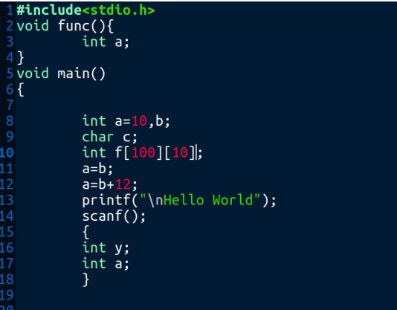

Output:

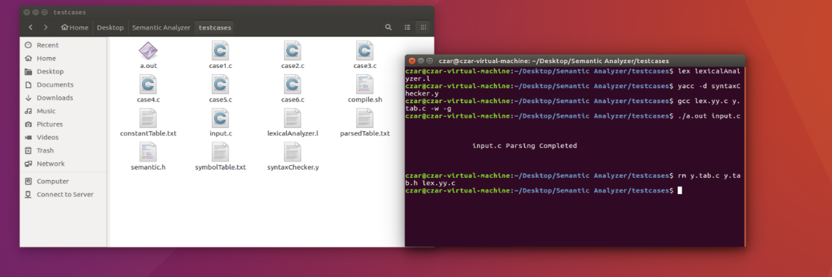

***Symbol Table:***

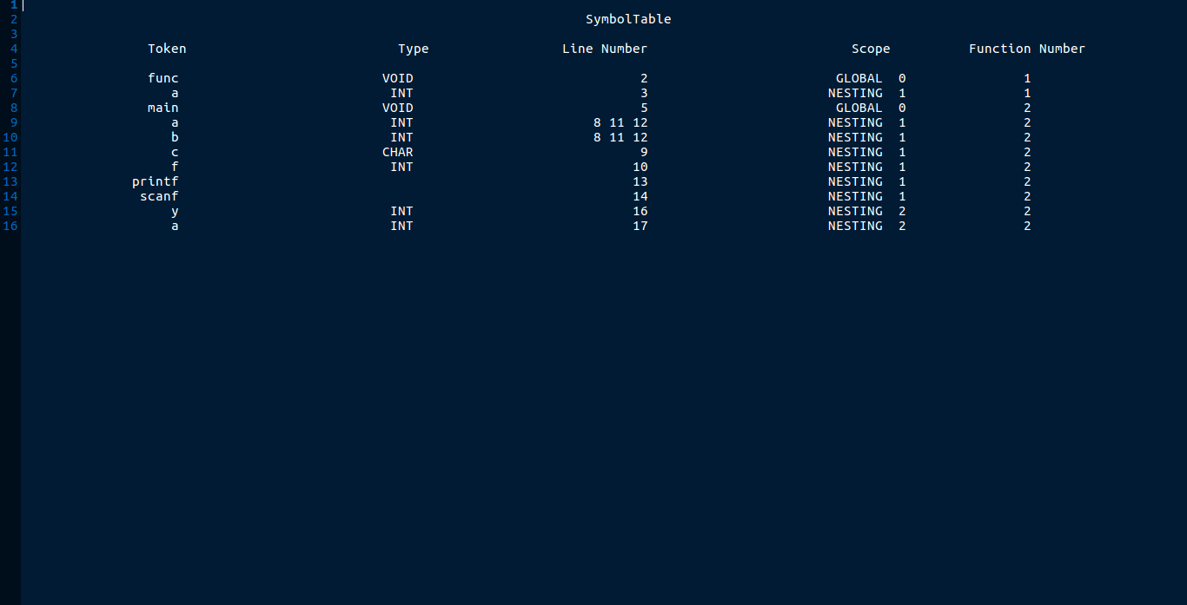

**Test Cases:**

Different test cases are added to check implementation of semantic phase. The validation of the same is done below in a table format. Source code for the 6 test cases is added as screenshot below.

Test Case Evaluation

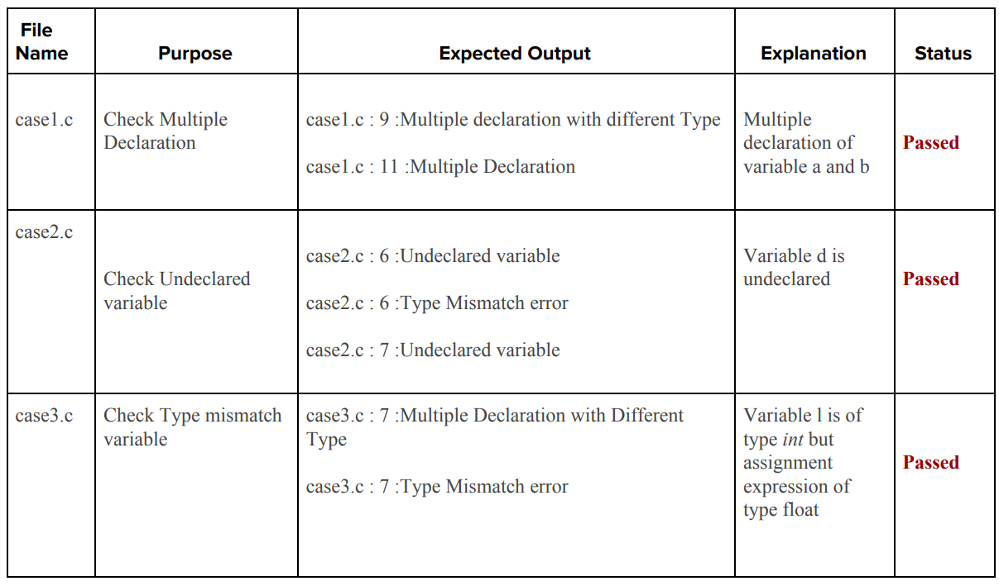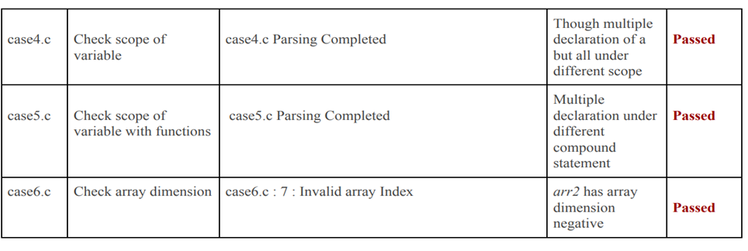

**Conclusion:**

After the third phase of this project, we have successfully implemented and added a Semantic Analyzer to the C Compiler. Semantic analysis checks whether the parse tree constructed follows the rules of language. Also, the semantic analyzer keeps track of identifiers, their types and expressions; whether identifiers are declared before use or not, etc. The semantic analyzer produces an annotated syntax tree as an output.

**INTERMEDIATE CODE GENERATION FOR C LANGUAGE**

**Introduction:**

Compilers generate machine code, whereas interpreters interpret intermediate code. Interpreters are easier to write and can provide better error messages (symbol table is still available). However, they are at least 5 times slower than machine code generated by compilers and also require much more memory than machine code generated by compilers. While generating machine code directly from source code is possible, it entails two problems:

1. With m languages and n target machines, we need to write m front ends, m × n optimizers, and m × n code generators
2. The code optimizer which is one of the largest and very-difficult-to-write components of a compiler, cannot be reused.

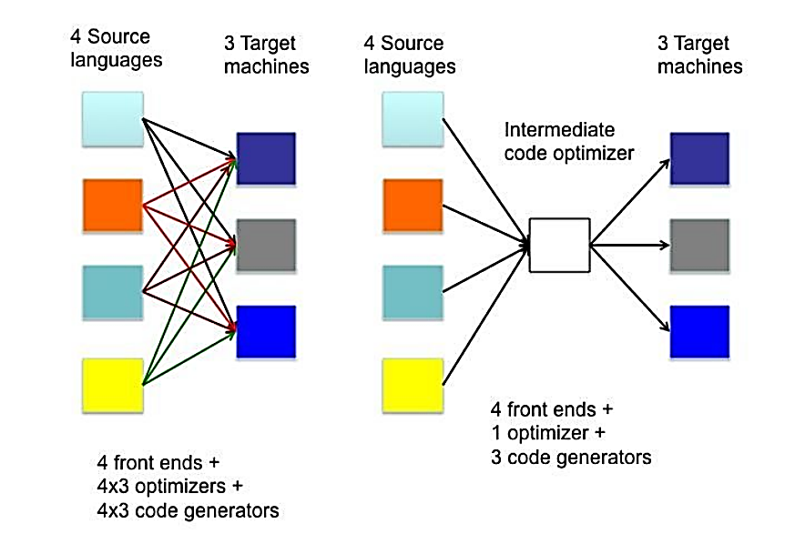

By converting source code to an intermediate code, a machine-independent code optimizer may be written. This means just m front ends, n code generators and 1 optimizer. A source code can directly be translated into its target machine code, but we need to translate the source code into an intermediate code which is then translated to its target code. The main reasons for this are:

1. If a compiler translates the source language to its target machine language without having the option for generating intermediate code, then for each new machine, a full native compiler is required.
2. Intermediate code eliminates the need of a new full compiler for every unique machine by keeping the analysis portion same for all the compilers.
3. The second part of compiler, synthesis, is changed according to the target machine.
4. It becomes easier to apply the source code modifications to improve code performance by applying code optimization techniques on the intermediate code.

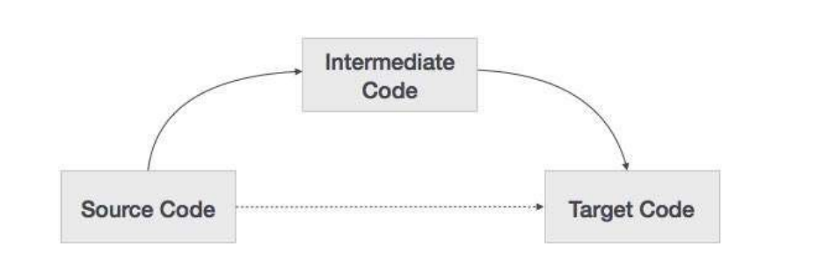

Intermediate code can be either language specific (e.g., Bytecode for Java) or language independent (three-address code).

**Intermediate Representation:**

The aim of Intermediate Code Generation is to translate the program into a format expected by the compiler back-end. Intermediate code must be easy to produce and easy to translate to machine code.

Why use an intermediate representation?

1. It’s easy to change the source or the target language by adapting only the front-end or back-end (portability).
2. It makes optimization easier: one needs to write optimization methods only for the intermediate representation.
3. The intermediate representation can be directly interpreted. Intermediate codes can be represented in a variety of ways and they have their own benefits.

*High Level IR -* High-level intermediate code representation is very close to the source language itself. They can be easily generated from the source code and we can easily apply code modifications to enhance performance. But for target machine optimization, it is less preferred.

*Low Level IR -* This one is close to the target machine, which makes it suitable for register and memory allocation, instruction set selection, etc. It is good for machine-dependent optimizations. Some general forms of intermediate representation are:

1) Graphical IR (parse tree, abstract syntax trees, DAG. . .)

2) Linear IR (ie., non-graphical)

3) Three Address Code (TAC): instructions of the form “result=op1 operator op2”

4) Static single assignment (SSA) form: each variable is assigned once

5) Continuation-passing style (CPS): general form of IR for functional language

**Three-Address Code:**

Intermediate code generator receives input from its predecessor phase, semantic analyzer, in the form of an annotated syntax tree. That syntax tree then can be converted into a linear representation, e.g., postfix notation. Intermediate code tends to be machine independent code. Therefore, code generator assumes to have unlimited number of memory storage (register) to generate code. The intermediate code generator will try to divide this expression into sub-expressions and then generate the corresponding code.

A statement involving no more than three references (two for operands and one for result) is known as three address statement. A sequence of three address statements is known as three address code. Three address statement is of the form x = y op z , here x, y, z will have address (memory location). Sometimes a statement might contain less than three references but it is still called three address statement. Example – The three address code for the expression a + b * c + d :

● T 1 = b * c

● T 2 = a + T 1

● T 3 = T 2 + d

where T 1 , T 2 , T 3 are temporary variables. A three-address code has at most three address locations to calculate the expression. A three-address code can be represented in two forms: quadruples and triples.

1. Quadruples - Each instruction in quadruples presentation is divided into four fields: operator, arg1, arg2, and result. Consider the example, a = b + c * d; It is represented below in quadruples format:

|  |  |  |  |
| --- | --- | --- | --- |
| Op | arg1 | arg2 | result |
| * | c | d | r1 |
| + | b | r1 | r2 |
| + | r2 | r1 | r3 |
| = | r3 |  | d |

1. Triples - Each instruction in triples presentation has three fields: op, arg1, and arg2.The results of respective sub-expressions are denoted by the position of expression. Triples represent similarity with DAG and syntax tree. They are equivalent to DAG while representing expressions.

|  |  |  |
| --- | --- | --- |
| Op | arg1 | arg2 |
| * | c | d |
| + | b | 0 |
| + | (1) | 0 |
| = | (2) |  |

Triples face the problem of code immovability while optimization, as the results are positional and changing the order or position of an expression may cause problems.

1. Indirect Triples - This representation is an enhancement over triples representation. It uses pointers instead of position to store results. This enables the optimizers to freely re-position the sub-expression to produce an optimized code.

**Implementation:**

When generating IR at this level, do not need to worry about optimizing it. It's okay to generate IR that has lots of unnecessary assignments, redundant computations, etc. All the lexical analyzer part are done in lexicalAnalyzer .l which returns each token along with its value or type based on whether it is variable or constant or keyword. Syntax and

semantic check has been done in syntax Checker.y. All the productions and respective semantic actions are written here. The functions that are generating intermediate code has been written in icg{.h,.c}. The main functions in icg files are

● three Address Code* append Code (char *code) Append the three-address code provided as argument to the main set of three address code

● void backpatch (back Patch List * list, int go to L) It is to add the line number “go to L” to back Patch List

● back Patch List* merge lists (back Patch List * a, back Patch List * b) It is to merge to back patch list if it is resolved.

● back Patch List* append To Back Patch (back Patch List * list, Three Address Code * entry) It is to append a single line three address code entry to the back patch list.

● token List* append To Symbol Table (char * name, token Type, token Return Type return Type, long size, long line, char * scope, long parameter) It is used add token “name” to the symbol table along with all the properties

● void write Code (FILE * icg Out)

This is writing the three-address code generated till now into a file provided as argument

● void write Symbol Table (FILE * sym Out)

This is to write the symbol table entries till now to the file provided as argument These functions are called from respective productions in syntaxAnalyzer.y whenever needed. All the code returned are stored in a global pointer such that can write it to a file at the end. The source code for the same has been provided below.

**Source Code:**

*Lexical Analyzer .l:* This is the lex program that contains regular expressions and returns whatever tokens arerequired.

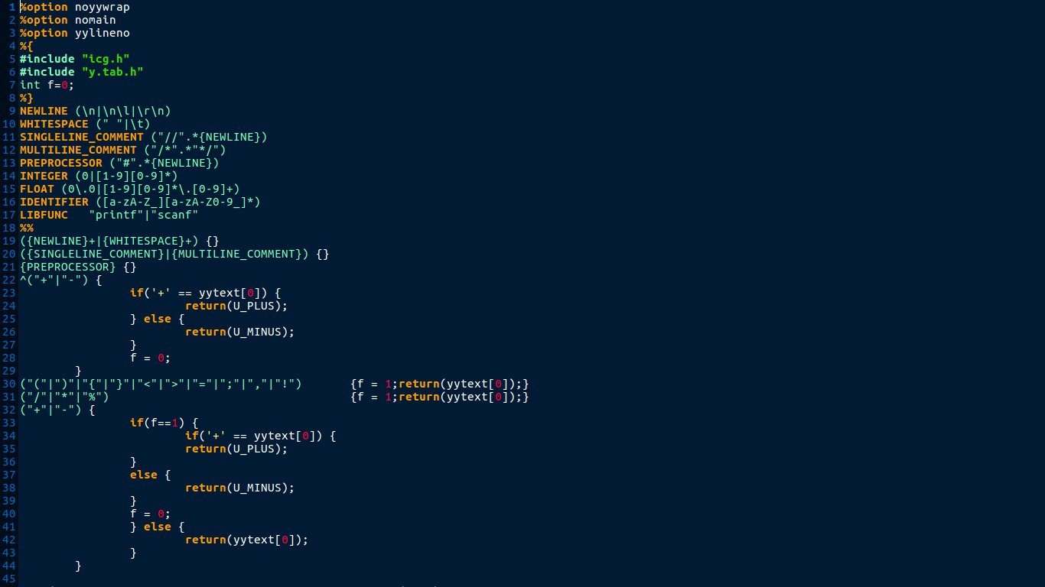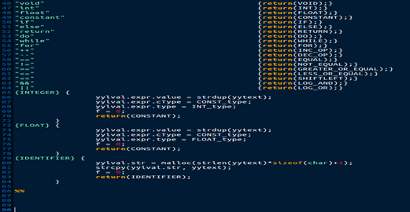

*Syntax Checker.y:* This is the main parser code, a yacc file which contains the declarations, rules and programs and defines the actions which should be taken for various cases.

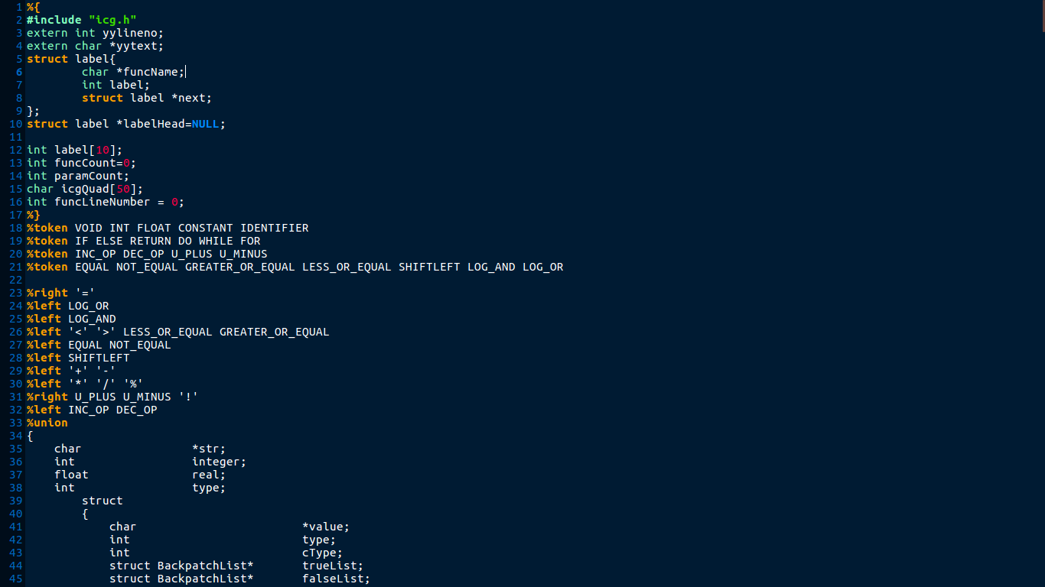

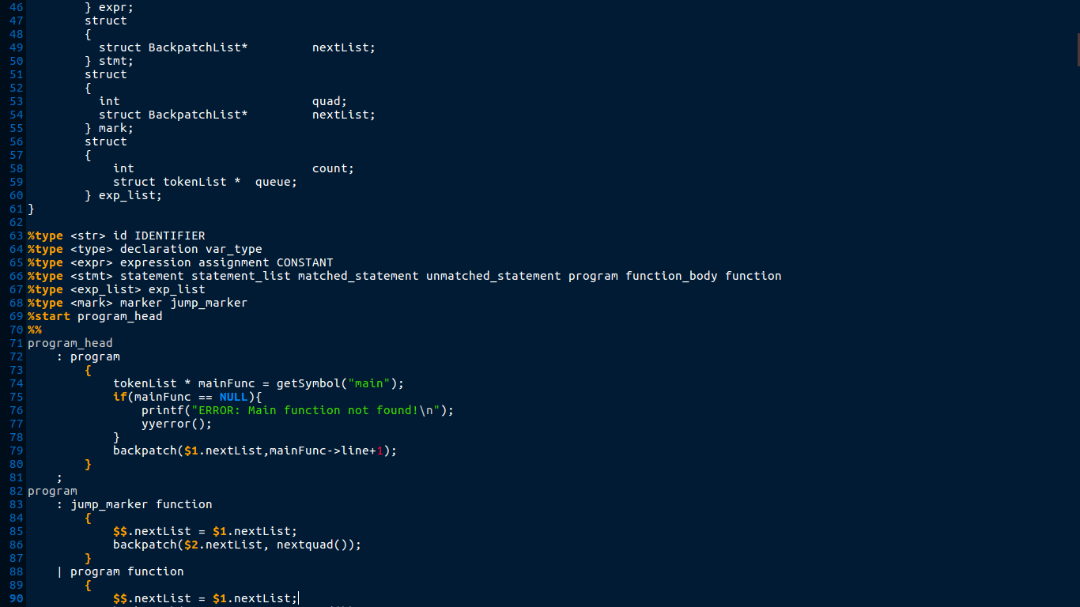

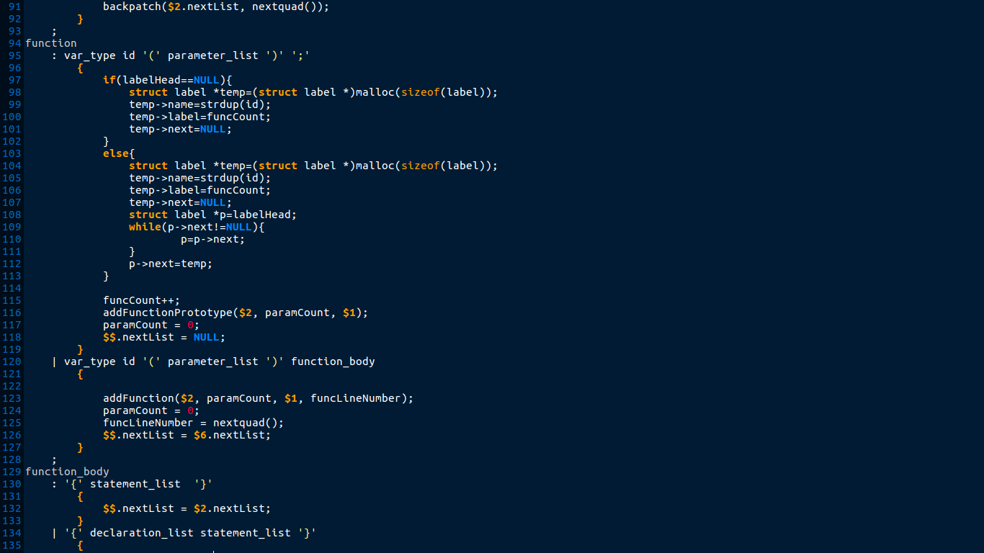

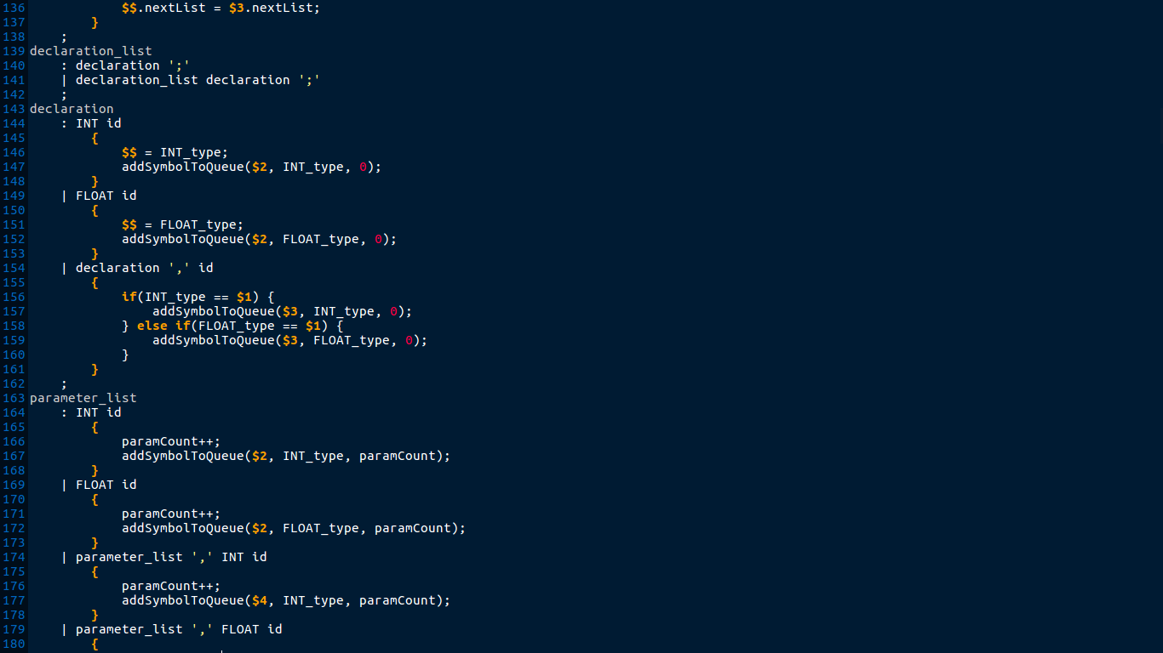

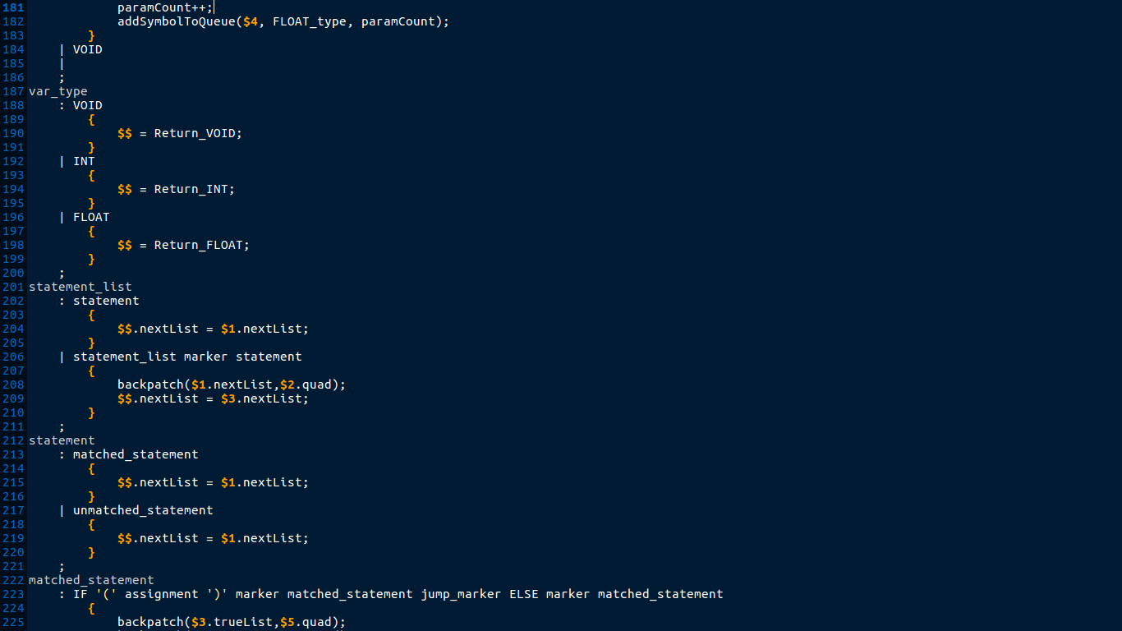

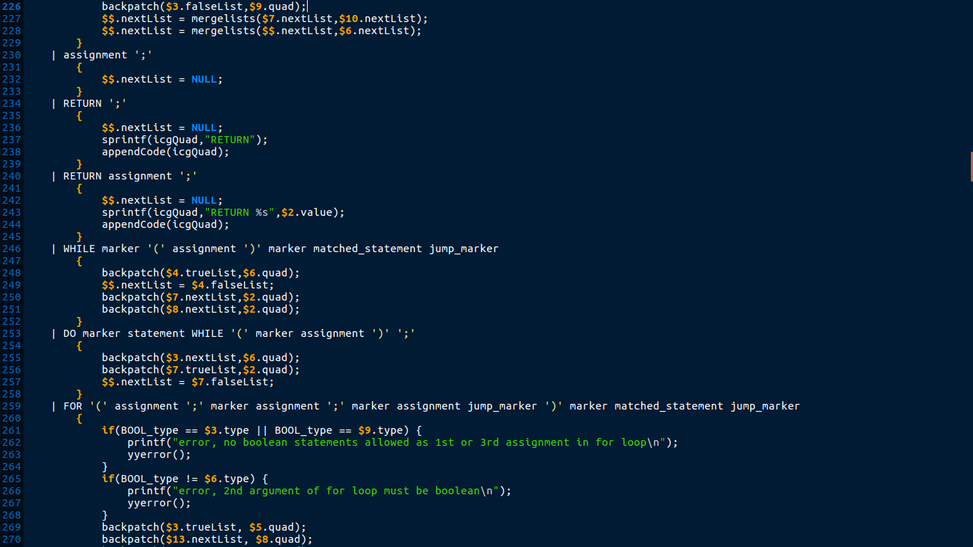

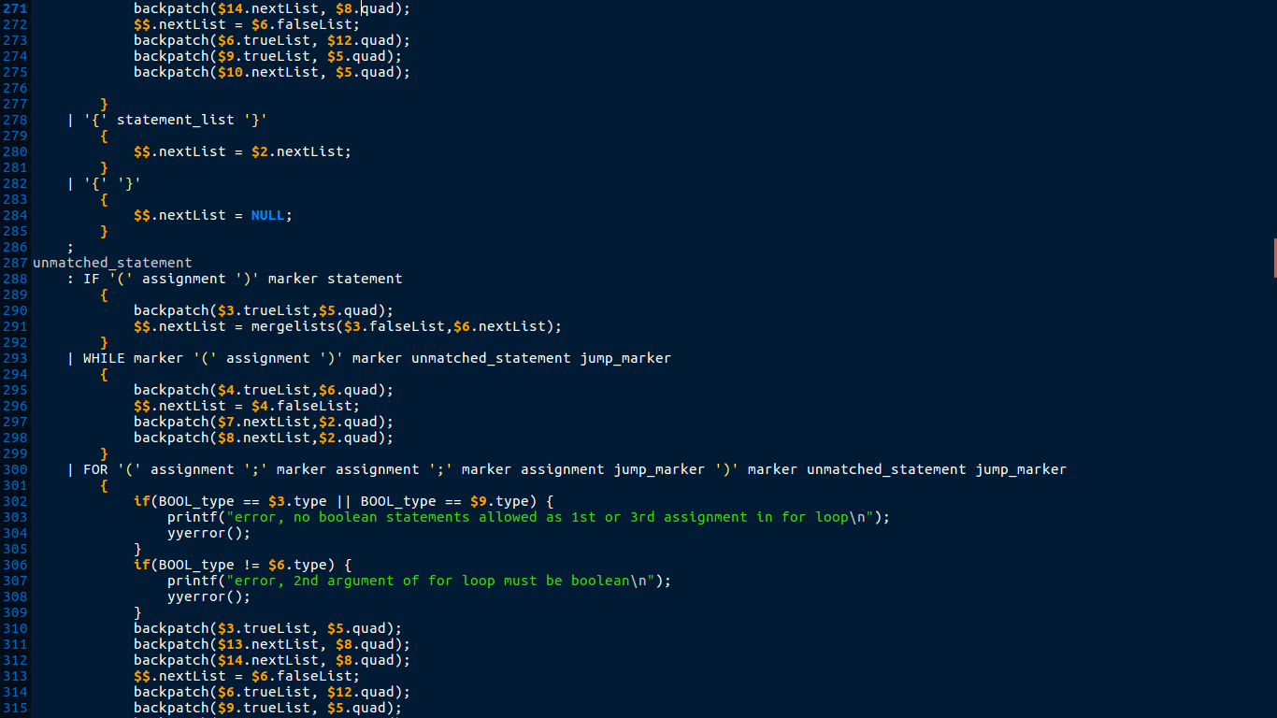

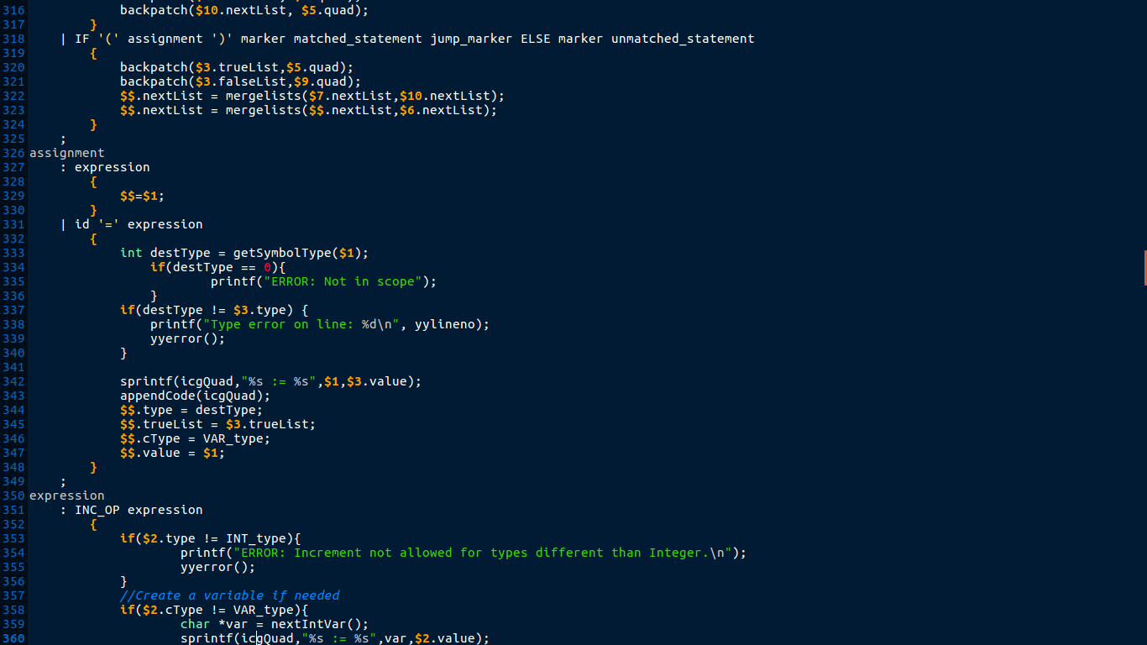

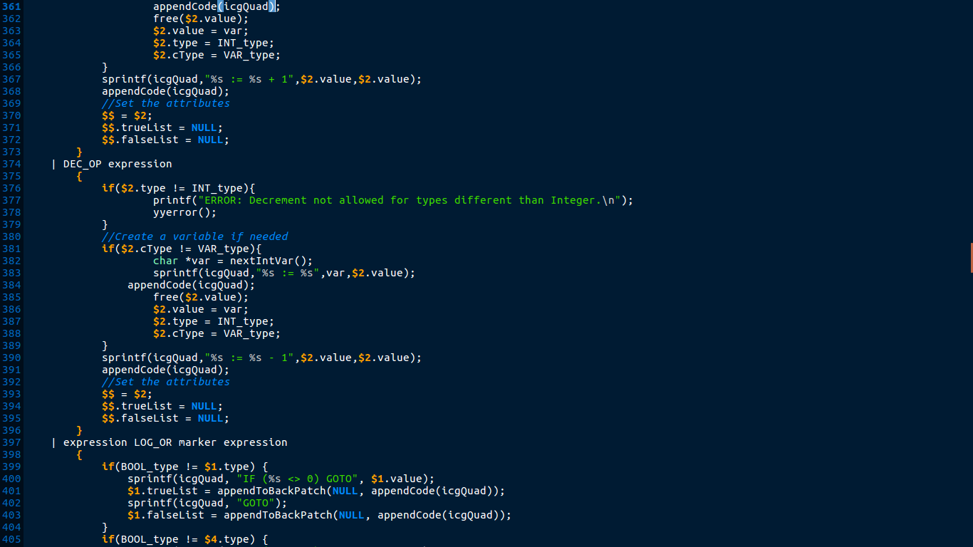

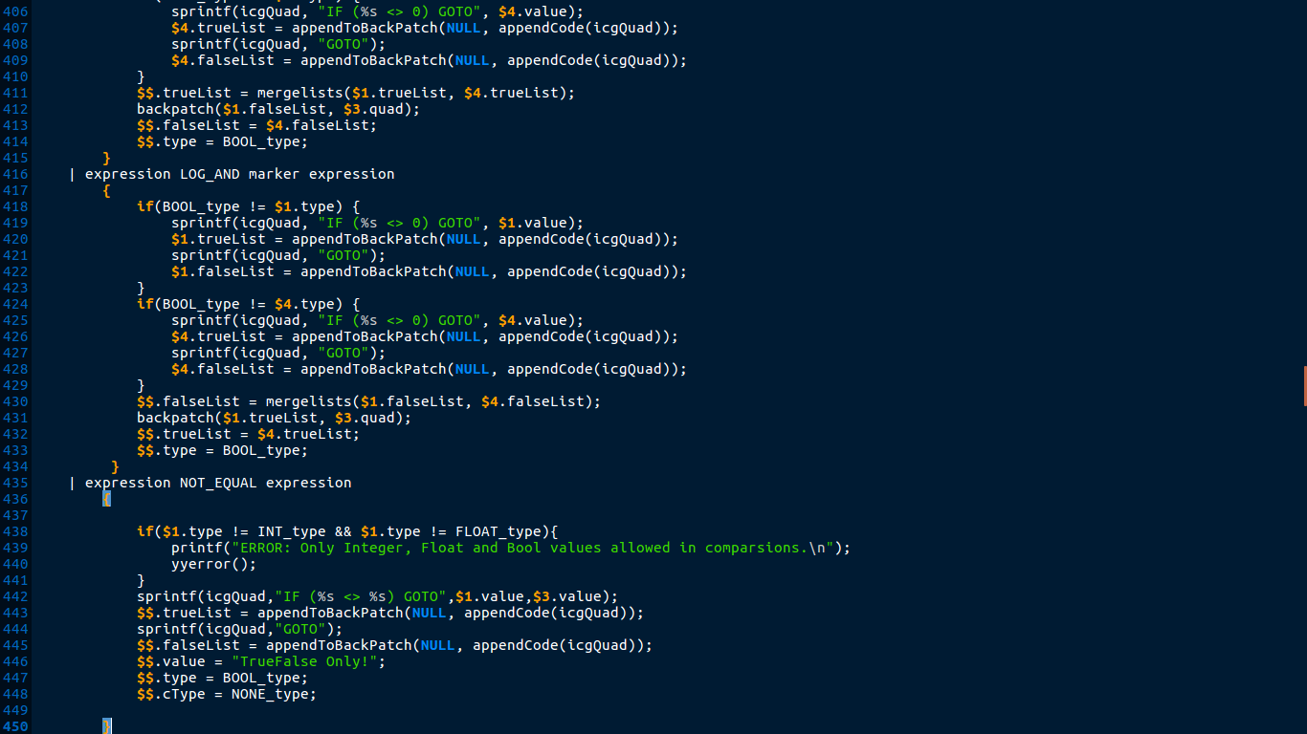

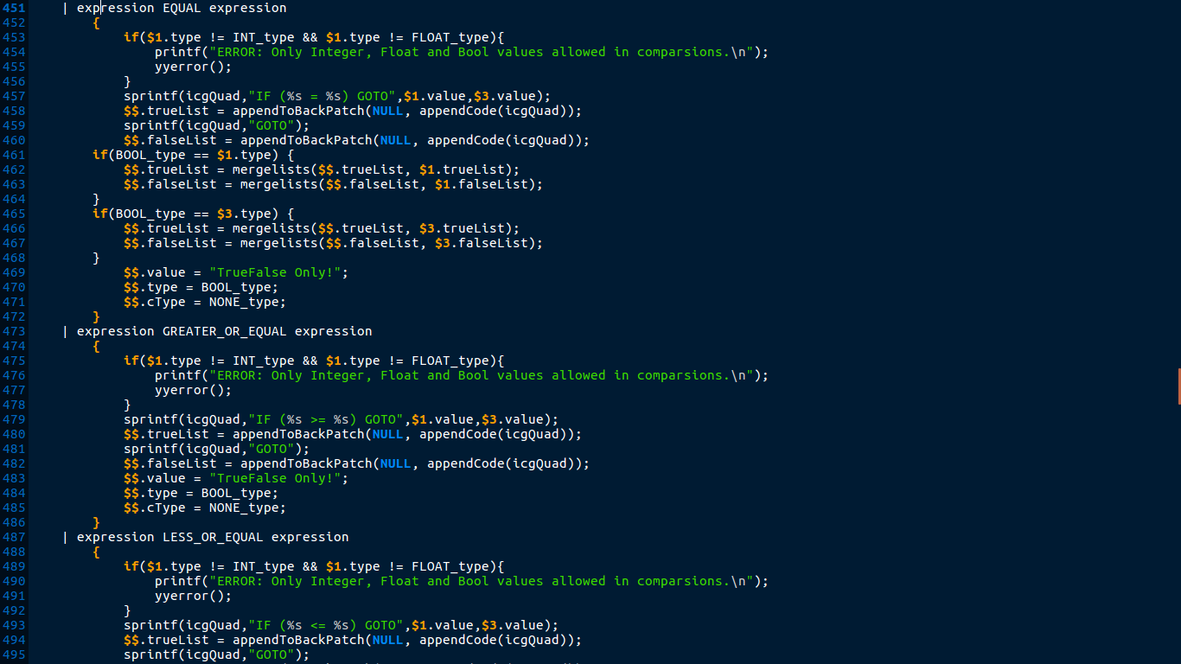

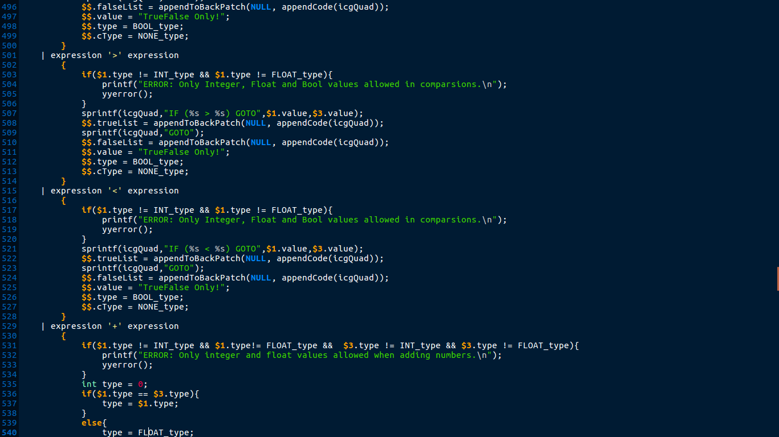

*icg.c*

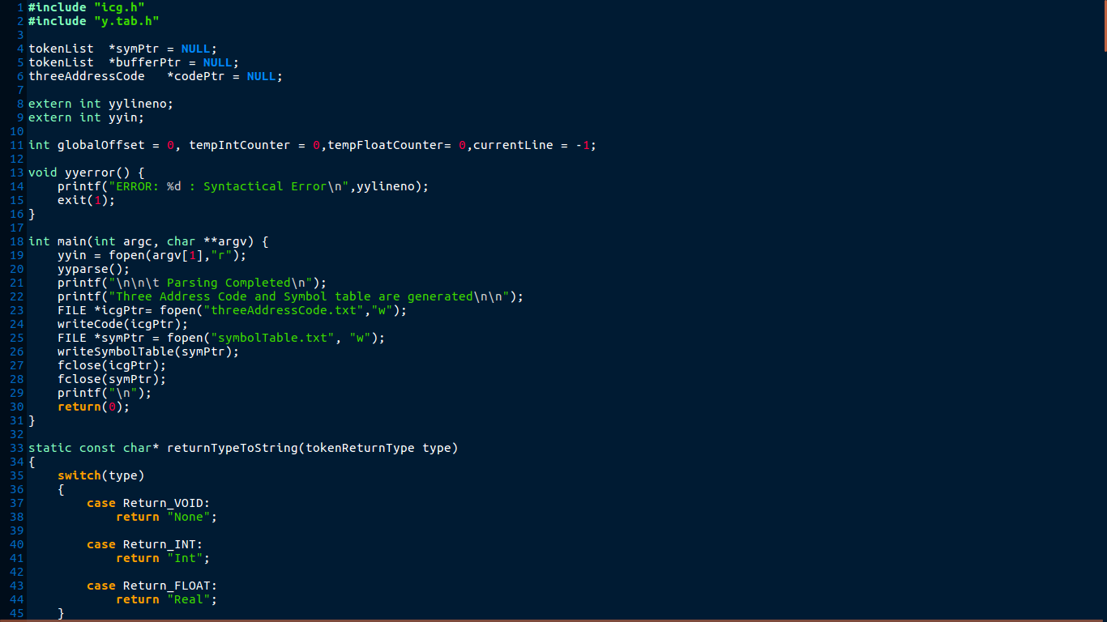

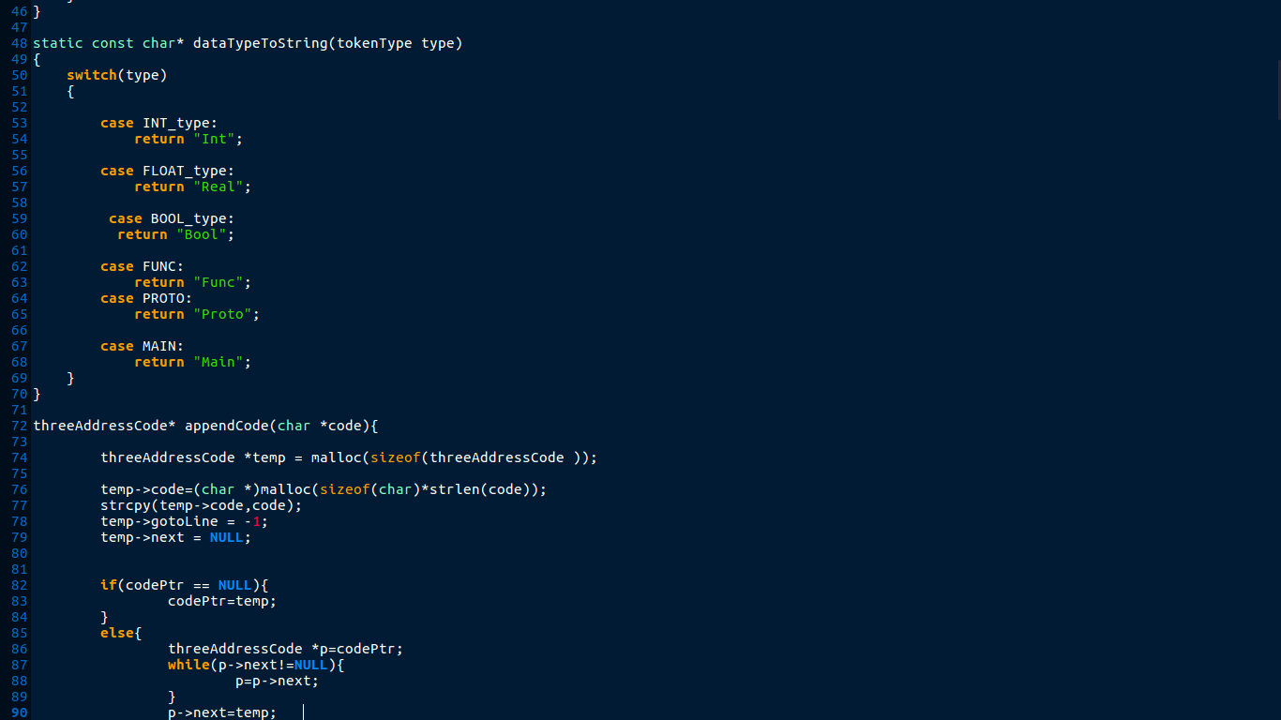

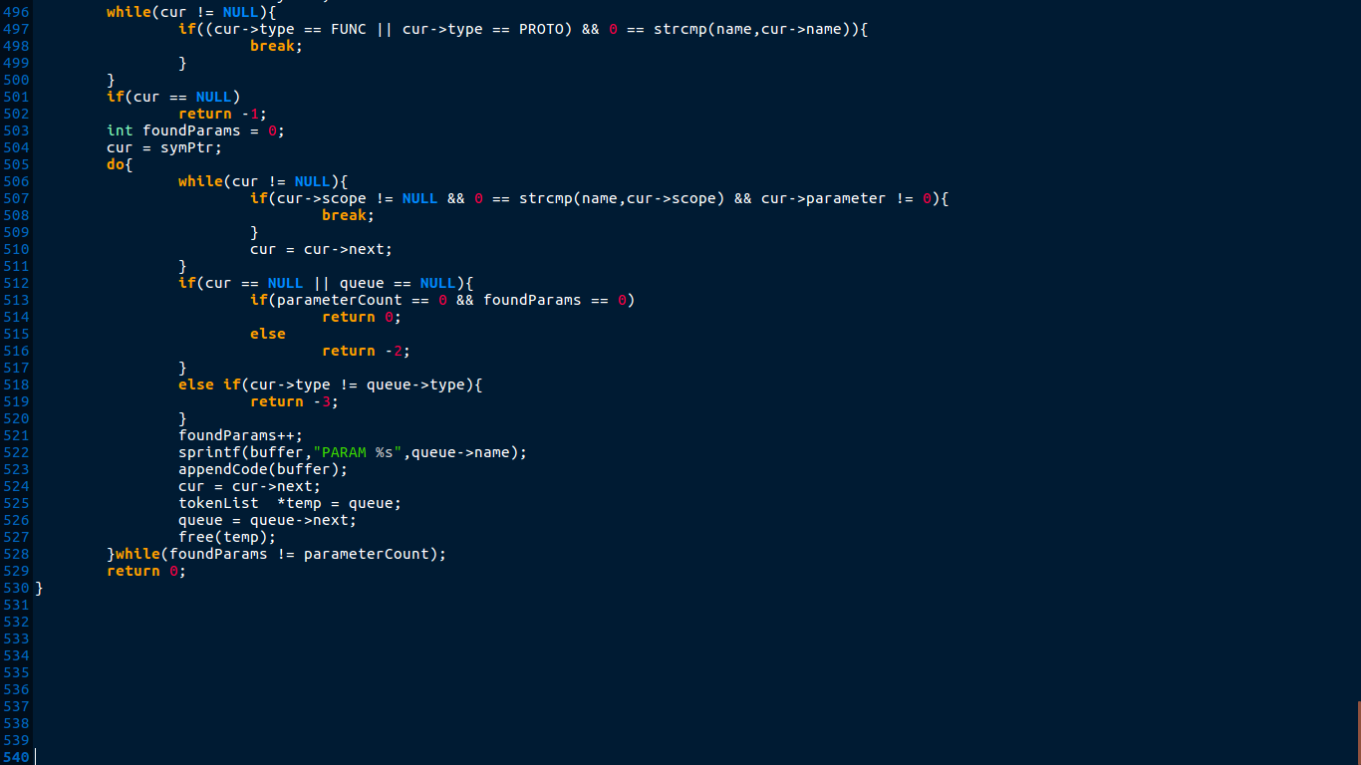

*icg.h*

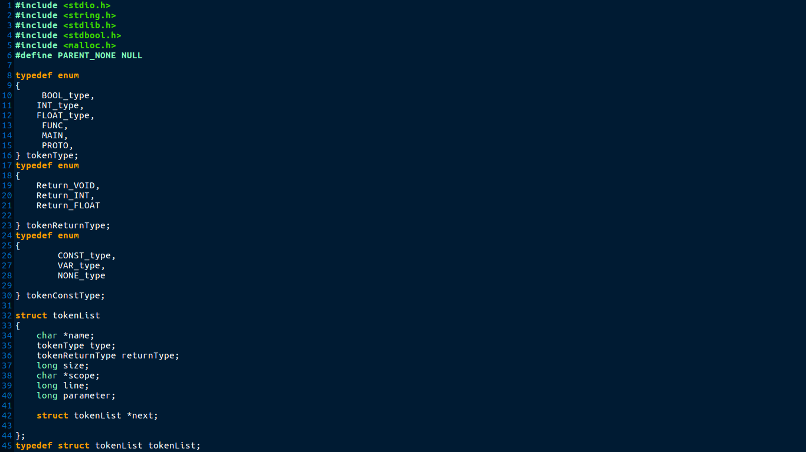

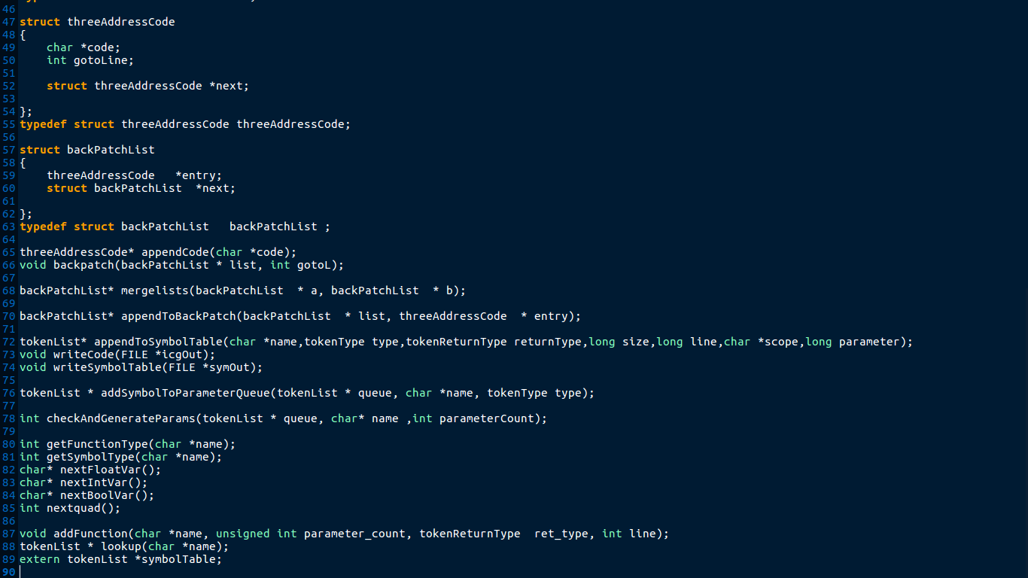

***Execution Of the Code:***

The following is a shell script to automate the compilation and execution of the mini compiler 24 consist of all phases. There is sample input source code given. Execution of the same is done and output is shown as sample output and respective symbol table is generated.

Shell Script:

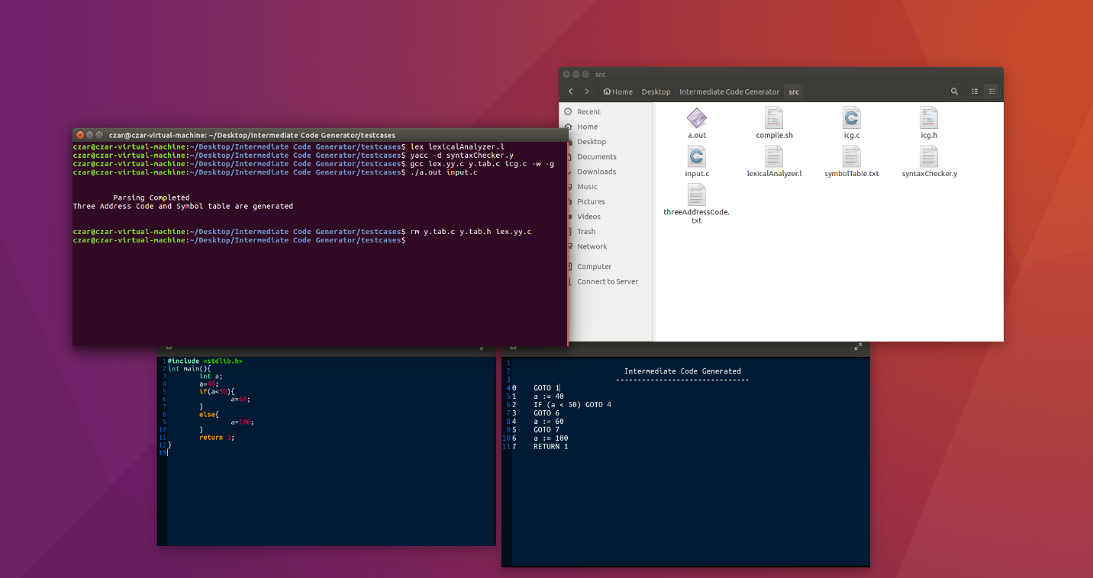

Symbol table:

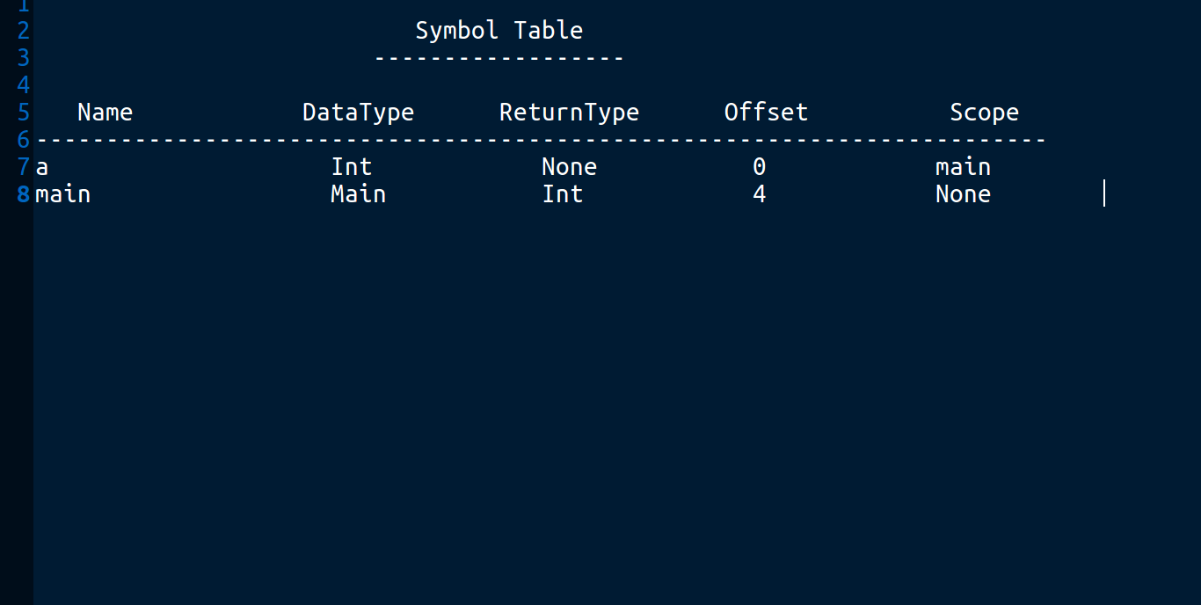

Sample Three-address Code:

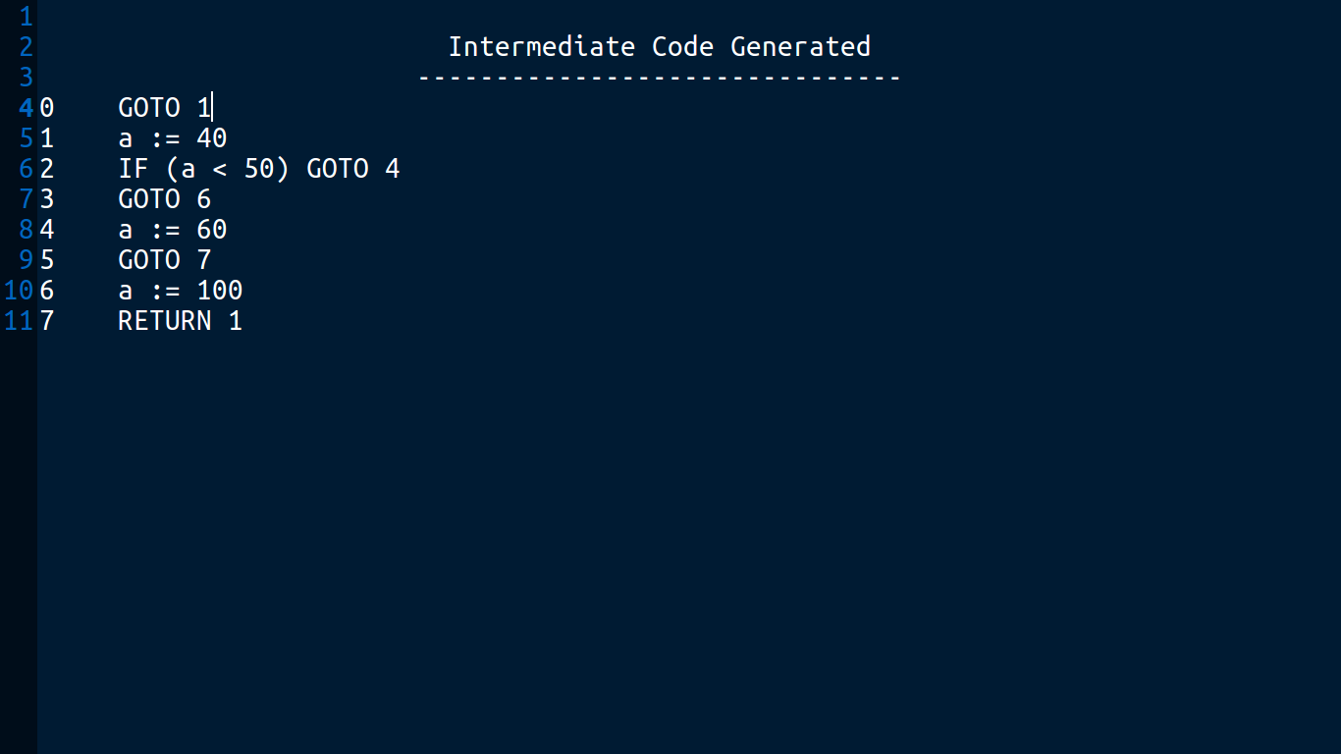

**Test Cases:**

Different test cases are added to check implementation of ICG phase. Source code for the 6 tests

cases are added as screenshot below along with their three-address code.

Case1.c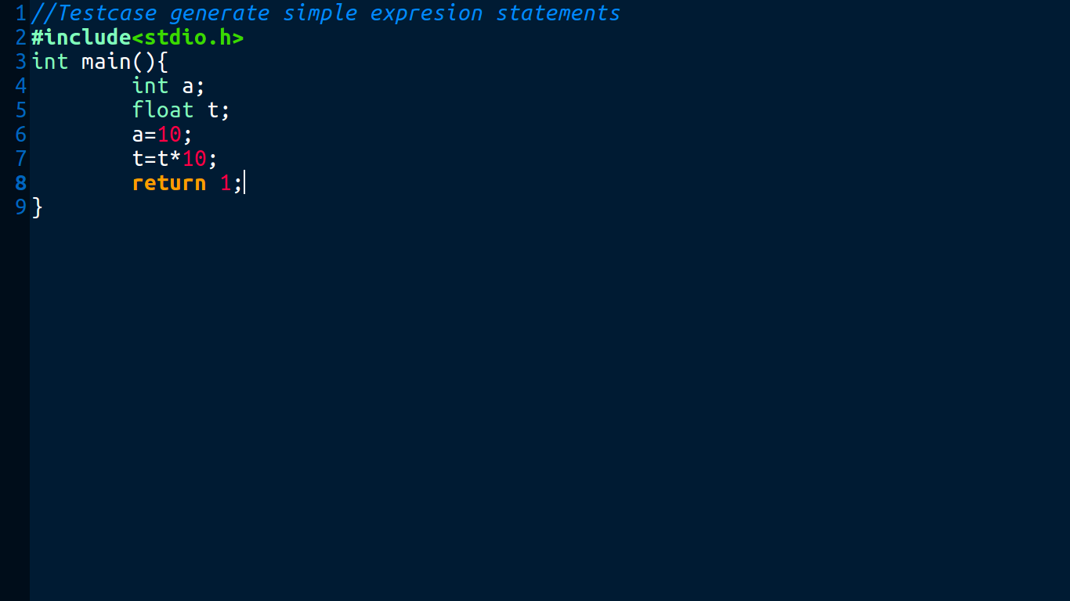

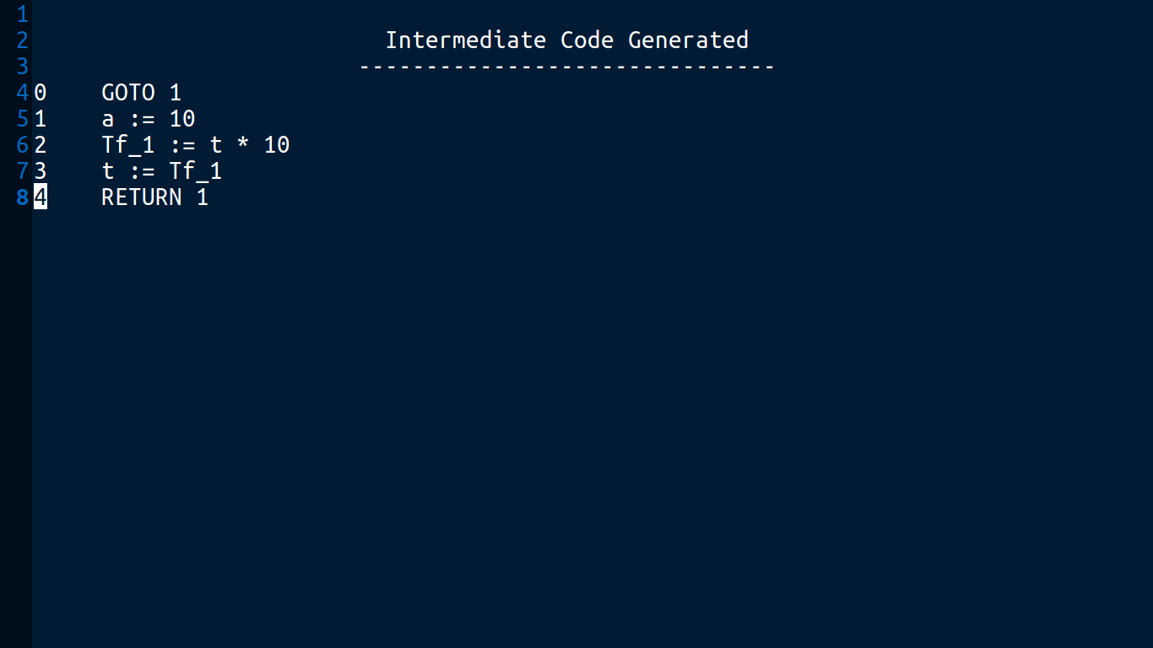

Case2.c

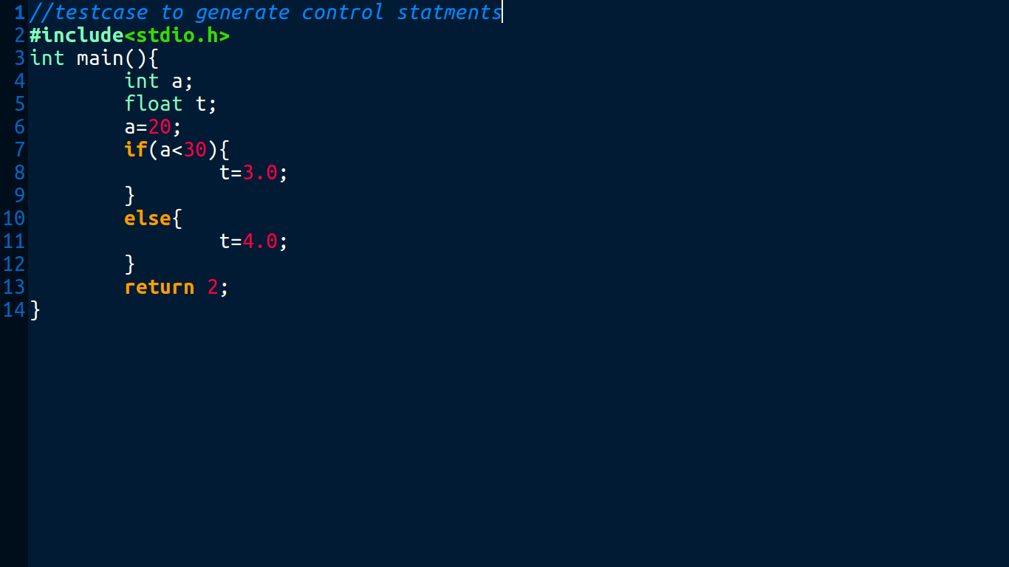

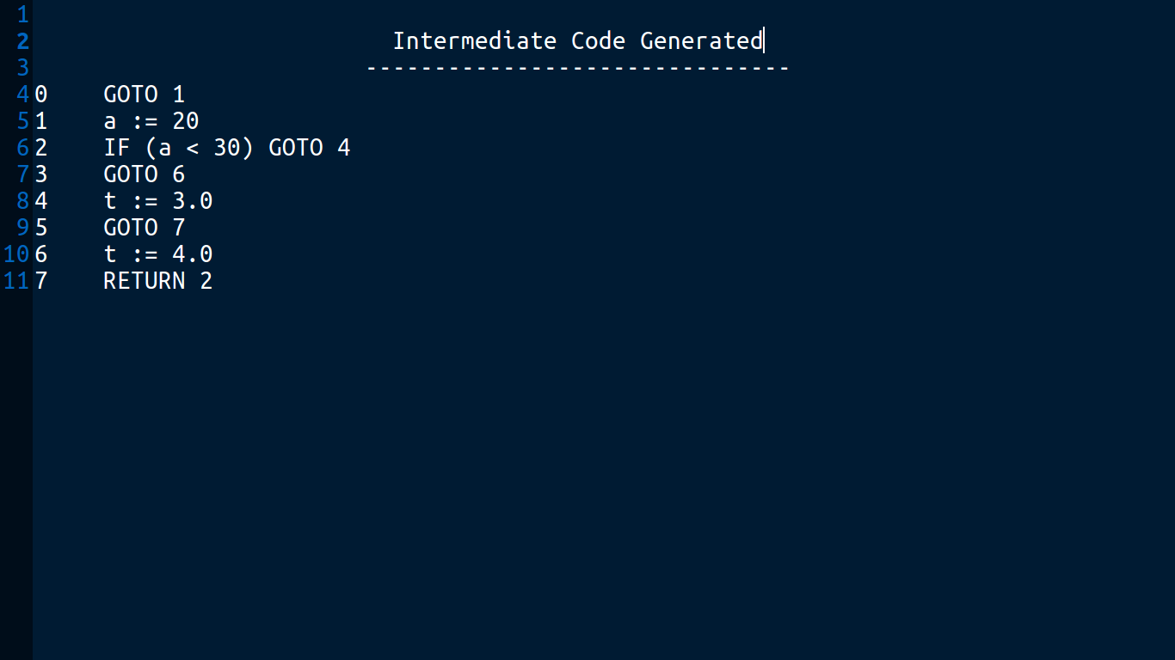

Case3.c

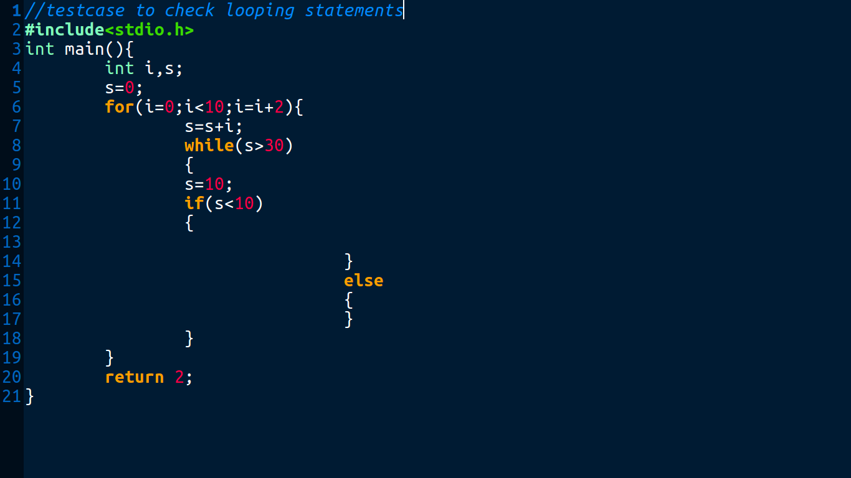

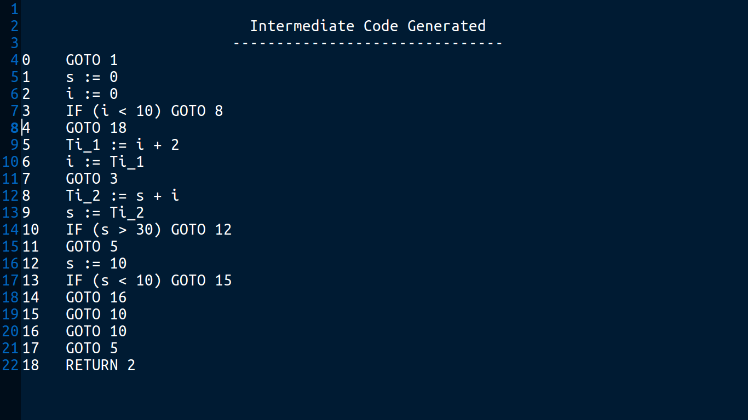

Case4.c

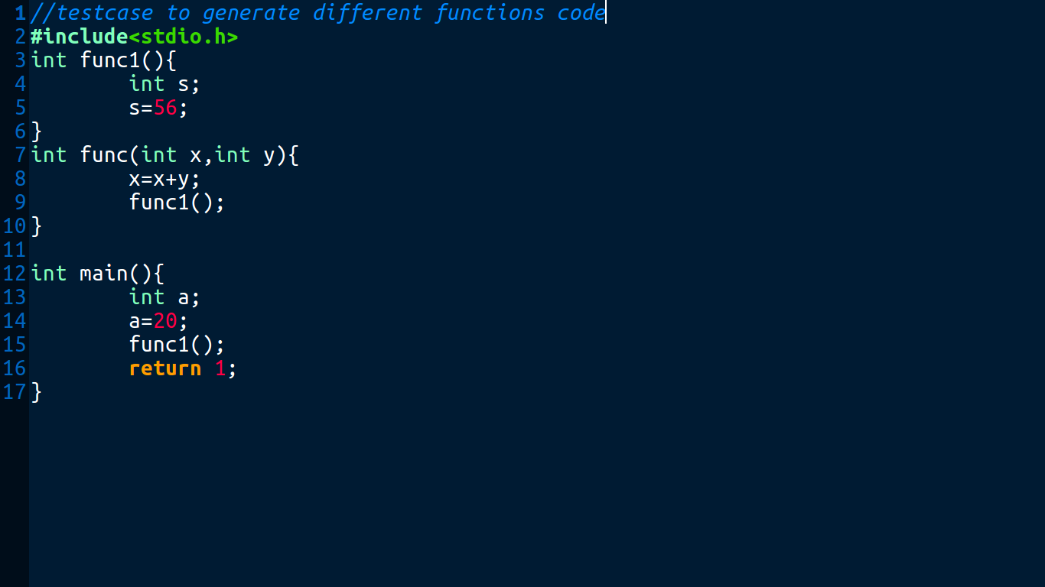

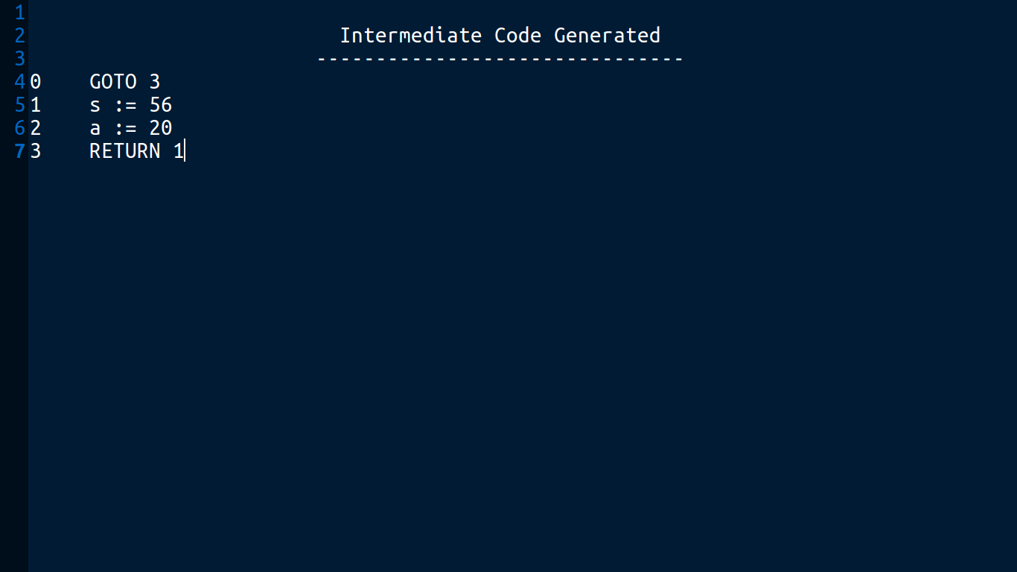

Case5.c

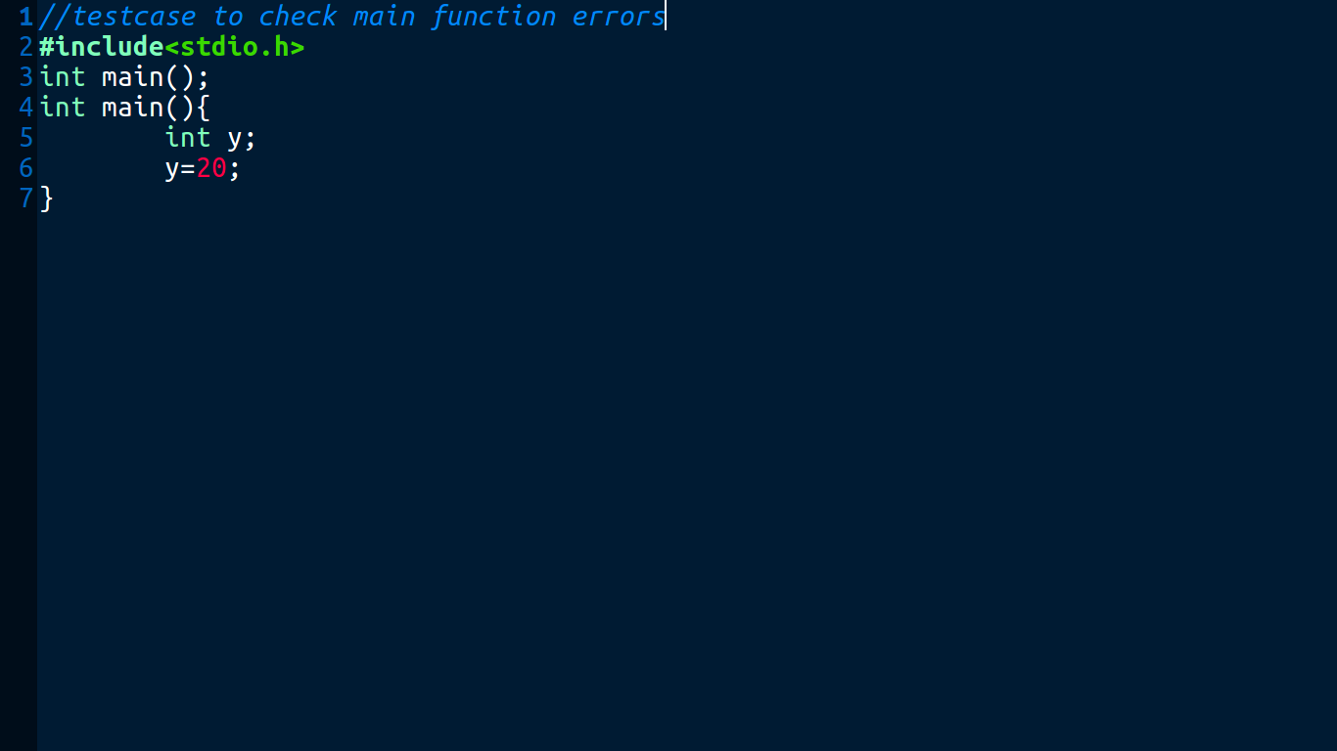

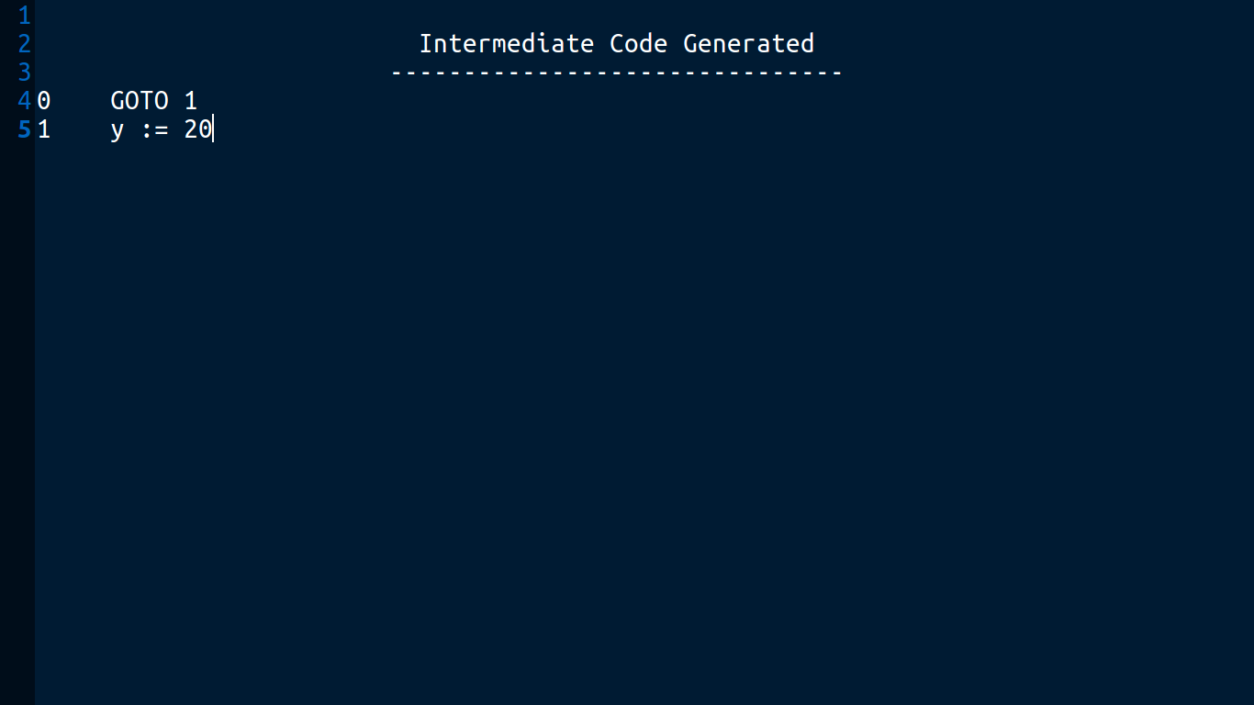

**Conclusion:**

Intermediate Code Generation (ICG) is the fourth phase of a compiler. It is the final phase of the front end of a compiler. It generates intermediate code, that is a form which can be readily executed by machine. Intermediate code is converted to machine language using the last two phases which are platform dependent. We can take the intermediate code from the already existing compiler and build the last two parts. After this, the intermediate code is ready and it is then sent to the Code Optimizer phase which transforms the code so that it consumes fewer resources and produces more speed.